Completed NASM CPT 4 Book Notes

Chapter 1 – The Scientific Rationale for Integrated Training

Overview of the Personal Training Industry
- Muscle Imbalance – Alteration of muscle length surrounding a joint. Examples: focusing heavily on building chest can cause muscle imbalances, causing the pectorals to be stronger than the surrounding muscles and cause you to have a hunched forward posture.
- Chronic disease – is responsible for 75 cents of every dollar spent on Health Care in the United States. It is defined as an incurable illness or health condition that persists for a year or more, resulting in functional limitations and the need for ongoing medical care.
- Obesity – Someone is considered obese when their body mass index(BMI) is 30 or greater, or they are at least 30 pounds over the recommended weight for their height. BMI is a really stupid way to measure obesity/overweight IMO because it simply takes into account weight and not weight from muscle/fat. I have a BMI of 27 so I’m overweight bordering on obese according to the BMI scales, at 9% bodyfat. What a stupid system. Anyways…
- According to “them” the desirable BMI for adults 20 and older is between 18.5 and 24.9
- 66% of Americans older than 20 are overweight, and 34% are obese, which means 72 million Americans are Obese! Crazy! But that means you’ll never want for money if you’re a good trainer.
- Overweight – People are overweight if they have a BMI of 25 to 29.9 or are between 25 to 30 pounds over the recommended weight for their height.
- Blood Lipids – Also known as cholesterol and triglycerides, are carried in the bloodstream by protein molecules known as high-density lipoproteins(HDL) and low-density lipoproteins(LDL). HDL is the good cholesterol, LDL is the bad cholesterol. Healthy cholesterol level is less than 200mg/dL. High cholesterol is more than 240mg/dL.
- Diabetes Mellitus – AKA Diabetes. A condition where blood glucose, AKA blood sugar, is unable to be absorbed into cells either because the pancreas is unable to produce insulin or the cells have become insulin resistant. Pancreas not producing insulin causes type I diabetes, insulin resistance causes type II diabetes. Type II diabetes is directly related to eating habits – constantly eating high carbohydrate meals along with low activity levels and poor body composition can lead to type II diabetes.
- Deconditioned – A state of lost physical fitness, which may include muscle imbalances, decreased flexibility, and a lack of core and joint stability. Or, being fat and out of shape.
- Proprioception – The cumulative sensory input to the central nervous system from all mechanoreceptors that sense body position and limb movement.
- Proprioceptively Enriched Environment – Unstable yet controllable physical situation in which exercises are performed that causes the body to use its internal balance and stabilization mechanisms. So a dumbbell bench press would be a proprioceptively enriched environment because your body needs to sense the position of the dumbbells and use its internal balance and stabilization mechanisms to make sure you don’t drop the weights and kill yourself.

Integrated Training and the OPT Model
- Integrated training – Incorporating all forms of training in an integrated fashion as part of a progressive system. The forms of training include flexibility, cardiorespiratory, core, balance, plyometric, speed, agility, quickness, and resistance training.
- The OPT Model – A training model for a society that has structural imbalances and a high susceptibility to injury. It is programming that systematically progresses any client to any goal.
- Physiological benefits – Improves cardiorespiratory efficiency, enhance endocrine(hormone) and serum lipid(cholesterol) adaptations, increase metabolism, increase bone density
- Physical benefits – Decrease body fat, increase lean body mass, increase tissue tensile strength(tendons, ligaments, muscles)
- Performance benefits – Strength, power, endurance, flexibility, speed, agility, balance
- Phases of training – Smaller divisions of training progressions that fall within the three building blocks of training. There are 5 phases of training and three building blocks.
- Stabilization level – phase 1 of training, stabilization endurance. Increase muscular endurance and stability while developing neuromuscular efficiency(coordination)
- Muscular endurance – Muscle’s ability to contract for an extended period.
- Neuromuscular Efficiency – Ability of neuromuscular system to enable all muscles to efficiently work together in all planes of motion.
- Goals of phase 1 stabilization endurance training – improve muscular endurance, enhance joint stability, increase flexibility, enhance control of posture, improve neuromuscular efficiency
- Training strategies of phase 1 stabilization endurance training – Train in unstable yet controllable environment (proprioceptively enriched), low loads, high reps.
- Strength level – phase 2, 3, and 4 of training. Follows the successful completion of stabilization training. The emphasis is to maintain stabilization endurance while increasing prime mover strength.
- Prime mover – The muscle that acts as the initial and main source of motive power.
- Phase 2 strength endurance training goals – improve stabilization endurance and increase prime mover strength, improve overall work capacity, enhance joint stabilization, increase lean body mass
- Phase 2 strength endurance training strategies – Moderate loads and reps(8-12), superset one traditional strength exercise and one stabilization exercise per body part in the resistance training portion of the program.
- Superset – Set of two exercises that are performed back-to-back without any rest time between them.
- Phase 3 hypertrophy training – Optional, depending on goals. Goal is to achieve optimal levels of hypertrophy(muscular growth). Strategy – high volume, moderate to high loads, moderate to low reps(6-12)
- Phase 4 maximum strength training – Optional. Goals – increase motor unit recruitment, increase frequency of motor unit recruitment, improve peak force. Strategy – High loads, low reps(1-5), longer rest periods
- Power level training – Should only be entered into after completion of stabilization and strength levels. Three levels are stabilization, strength, and power. Power emphasizes speed and power.
- Phase 5 power training – Execution of traditional strength exercises with a heavy load superset with power exercises with a light load performed as fast as possible(plyo).
- Rate of Force Production – Ability of muscles to exert maximal force output in a minimal amount of time

Chapter 2 – Basic Exercise Science

Introduction to Human Movement
- Human movement is accomplished through the integration of the nervous, skeletal, and muscular systems. The nerves, muscles, and joints must work together in a chain to produce motion(kinetic). These three systems are also referred to as the kinetic chain.
- Human Movement System – The combination and interrelation of the nervous, muscular, and skeletal systems.
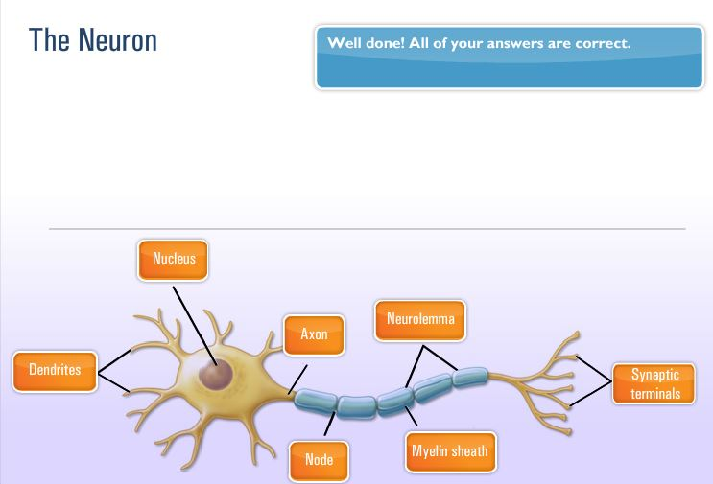

The Nervous System
- Nervous system – One of the main organ systems of the body. Conglomeration of billions of cells specifically designed to provide a communication network within the human body. The CNS is composed of the brain and spinal cord. The peripheral nervous system(PNS) contains only nerves and connects the brain and spinal cord(the CNS) to the rest of the body.
- Sensory function – Ability of the nervous system to sense changes in either internal or external environment. One of three primary functions of the nervous system.
- Integrative function - Ability of nervous system to analyze and interpret sensory information to allow for proper decision making, producing an appropriate response.
- Motor function – Neuromuscular (nervous and muscular system) response to sensory information. I.e. causing muscle contraction when you touch a hot stove so that you jerk your hand back.
- The nervous system is responsible for the recruitment of muscles, learned patterns of movements, and the functioning of every organ in the human body. Pretty important!
- Proprioception – Cumulative sensory input to the central nervous system from all mechanoreceptors that sense body position and limb movement. When you run your feet give you proprioceptive feedback on the type of surface you’re running on. Training proprioception improves balance, coordination, and posture.

Anatomy of the Nervous System
- Neuron – Functional unit of the nervous system. Billions of neurons make up nervous system, provides it with ability to communicate internally with itself as well as externally with environment. Transmits impulses through both electrical and chemical signals. Forms the core of the nervous system which includes the brain, spinal cord, and peripheral ganglia.
- Neurons are composed of cell body, axon, and dendrites.
- The cell body of Neuron contains a nucleus, lysosomes, mitochondria, and a Golgi complex.
- Axon – cylindrical projection from the cell body that transmits nervous impulses to other neurons or effector sites(muscles, organs). Provides communication from brain and spinal cord to other parts of the body.
- Dendrites – gather information from other structures and transmit it back into the neuron.
- Sensory (afferent) neurons – Respond to touch, sound, light, and other stimuli and transmit nerve impulses from effector sites(muscles, organs) to the brain and spinal cord.
- Interneurons – Transmit nerve impulses from one neuron to another. Hence INTER neuron. Between neurons.
- Motor (efferent) neurons – transmit nerve impulses from the brain and spinal cord to the effector sites such as muscles or glands.
- So sensory neurons transmit from muscles and organs to the CNS. Motor neurons transmit nerve impulses from CNS to muscles and organs. Interneurons transmit impulses between neurons.

The Central and Peripheral Nervous System
- The nervous system is composed of two interdependent divisions, the CNS and the PNS.
- Central Nervous System – Consists of the brain and the spinal cord, and its primary function is to coordinate the activity of all parts of the body.
- Peripheral Nervous System – Nerves that connect the CNS to the rest of the body and the external environment. Nerves of PNS are how CNS receives sensory input(from sensory afferent neurons) and initiates responses(through motor efferent neurons).
- The PNS serve two main functions. They provide a connection for the nervous system to activate different effector(organ, muscle) sites. Second they relay information from effector(organ, muscle) sites back to the brain via sensory receptors, providing constant update to the relation of the body and the environment.
- The PNS consists of the somatic and autonomic nervous system.
- The somatic nervous system consists of the nerves that serve the outer areas of the body and skeletal muscle and are responsible for the voluntary control of movement. So somatic is what controls your biceps and legs and whatnot.
- The autonomic nervous system supplies neural input to the involuntary systems of the body, like your heart. Autonomic, auto, think autopilot, you don’t have conscious control over the autonomic process.
- The autonomic is divided into sympathetic and parasympathetic nervous systems.
- The sympathetic system increases the activation level of neurons in preparation for activity(ramps you up).
- The parasympathetic ramps your system down, decreases levels of activation.
- Sensory receptors are specialized structures that convert environmental stimuli(heat, sound, taste, etc) into sensory information for the brain. These receptors are divided into four categories, mechanoreceptors, nociceptors, chemoreceptors, and photoreceptors.
- Mechanoreceptors – specialized structures that respond to mechanical pressure within tissues and then transmit signals through sensory nerves. Respond to outside forces such as touch, pressure, stretching, sound waves, and motion. Senses distortions in body tissues.
- Muscle Spindles – Sensory receptors, run parallel to muscle fibers. Are sensitive to changes in muscle length and rate of length change. Help regulate the contraction of muscles via the stretch reflex mechanism. This mechanism is a normal response to the body to a stretch stimulus in the muscle, it is designed to protect and prevent overstretching and muscle damage.
- Gogli Tendon Organs(GTOs) – Specialized sensory receptors located where the skeletal muscle fibers attach to the tendons. Sensitive to changes in muscular tension and rate of tension change. Activating the Gogli tendon organ causes the muscle to relax which prevents the muscle from excessive stress or injury.
- Joint receptors – located around joint capsule, respond to pressure, acceleration, and deceleration of the joint. Signals extreme joint positions and thus helps prevent injury.
- Performance increases in early stages of training result from changes in the way the CNS controls and coordinates movement. Unsuccessful performances can be cross referenced with other sensory input and new movement strategies found. Regular training causes adaptations int he CNS, allowing greater control of movements, thus causing movements to be more smooth and more accurate – improving performance.

Skeletal System
- Skeletal System – Body’s framework, composed of bones and joints. Provides shape and focus for bodies. Produces blood for the body and stores minerals. Growth, maturation, and functionality of skeletal system are greatly affected by posture, physical activity, and nutrition.
- Bones – Provide a resting ground for muscles and protection of vital organs.
- Joints – Junctions of bones, muscles, and connective tissues at which movement occurs. Also known as articulation.
- The skeletal system is divided into two divisions.
- Axial Skeleton – Portion of skeletal system that consists of skull, rib cage, and vertebral column. Think torso and head. 80 bones.
- Appendicular Skeleton – Portion of skeletal system that includes the upper and lower extremities. Arms, legs. Think appendage, appendicular, arms, legs. 126 bones.
- 206 bones in the skeletal system, 177 used in voluntary movement, more than 300 joints in the body.
- Bones serve two vital functions – leverage and support.
- Remodeling – Process of resorption and formation of bone. Old bone is broken down and removed by osteoclasts, new bone is laid down by cells called osteoblasts.
- Osteoclasts – Bone cell that removes bone tissue. Clast. Osteoclasts get rid of bone.
- Osteoblasts – Bone cell that forms bone. Blast. You like having a blast. You like building bone. Osteoblasts build bone.
- Remodeling follows lines of stress placed on bone. Exercise and habitual posture fundamentally influences the health of the skeletal system. Incorrect exercise and posture will lead to remodeling process that reinforces predominating bad posture.

Types of Bones
- Five major types of bones. Shape, size, and proportion determine their classification.
- Long bones – long cylindrical body, irregular or widened ends. Shaped like a beam and have slight curvature. Predominantly composed of compact bone tissue for strength and stiffness. Has considerable amount of spongy tissue for shock absorption.
- Epiphysis – End of long bones, mainly composed of cancellous bone and house much of the red marrow involved in red blood cell production. One of primary sites for bone growth. End of long bones, red marrow which produces red blood cells. Knobby end looking parts of the bone.
- Diaphysis – Shaft portion of long bone. The shaft. Long part. Compact bone(strong).
- Epiphyseal Plate – Region of long bone connecting the diaphysis to the epiphysis. A layer of subdividing cartilaginous cells in which growth in length of the diaphysis occurs.
- Periosteum – Dense membrane composed of fibrous connective tissue that closely wraps (invests) all bone, except that of the articulating surfaces in joints, which are covered by a synovial membrane. Inner surface provides materials for nutrition repair and facilitates growth in the diameter of the bone.
- Medullary cavity – Central cavity of bone shafts where marrow is stored. Contains fatty yellow marrow, predominantly fat and serves as energy reserve, center of diaphysis.
- Articular (hyaline) cartilage – Covers the articular surfaces of bones. “articular surface” means the parts of the bone that moves in joints. Hard, white, shiny tissue that along with synovial fluid helps reduce friction in freely moving synovial joints. Fundamental to smooth joint action.
- Short bones – Similar in length and width. Somewhat cubical in shape. Consist predominantly of spongy bone tissue to maximize shock absorption. Carpals of hands and tarsals of feet.
- Flat bones – Thin bones, two layers of compact bone tissue surrounding a layer of spongy bone tissue. Involved in protection of internal structures and also provide broad attachment sites for muscles. Sternum, scapulae, ribs.
- Irregular bones – Unique shape and function. Vertebrae, pelvic bones, facial bones.
- Sesamoid Bones - Small bones embedded in a joint capsule or found in locations where tendon passes over a joint. Develop within particular tendons at a site of considerable friction or tension. Serve to improve leverage and protect the joint from damage.

Bone Markings
- Bones have specific distinguishing structures called surface markings. They increase stability in joints as well as provide attachment sites for muscles. Divided into depressions and processes.
- Depressions – Flattened or indented portions of bone, which can be muscle attachment sites. Indents. Grooves.
- Processes – Projections protruding from the bone where muscles, tendons, and ligaments can attach. Part that sticks out on bones. Where there is a depression on both sides will generally be processes.

Vertebral Column
- Vertebral Column – Backbone, spinal column, series of irregularly shaped bones called vertebrae that houses spinal cord.
- First seven vertebrae starting from top are cervical vertebrae, flexible framework and provide support and motion for the head(your neck, basically).
- Next 12 are upper and middle back, called thoracic vertebrae, move with the ribs to form rear anchor of rib cage. Larger than cervical vertebrae and increase in size from top to bottom.
- Next five are lumbar vertebrae. Largest in spinal column, support most of the body’s weight and attached to back muscles, often location of pain because they are subject to largest forces and stresses.
- The sacrum is a triangular bone located below lumbar vertebrae, four or five sacral vertebrae in a child which become fused into a single bone during adulthood.
- Bottom of spinal column is coccyx or tailbone, 3 to 5 bones fused together.
- Intervertebral discs are fibrous cartilage that act as shock absorbers and allow the back to move.
- Optimal arrangement of curves is referred to as a neutral spine. Vertebrae and associated structures under the least amount of load.

Joints
- Formed by one bone that articulates with another bone. Categorized by structure and function.
- Arthrokinematics – Joint motion. Rolled, slide, and spin. Motions rarely occur in isolation. Rolling movement – bicycle roll on street. Sliding – tire skidding on street. Spinning movement – twisting lid off a jar.
- Synovial joints – Held together by a joint capsule and ligaments and are most associated with movement in the body. 80% of all joints in the body, have greatest capacity for motion. Produce synovial fluid, resembles egg whites and works like engine oil.
- Nonsynovial joints – do not have a joint cavity, connective tissue, or cartilage. Exhibit little to no movement, seen in skull, distal joint of tibia and fibula.
- Ligaments – Primary connective tissue that connects bones together and provides stability, input to the nervous system, guidance, and the limitation of improper joint movement. Fibrous connective tissues, bone to bone, provide static and dynamic stability as well as input to nervous system (proprioception). Made up of collagen. Ligaments have poor vascularity, blood flow, thus do not heal or repair well.

The Muscular System
- Muscular system – series of muscles that move the skeleton. Muscles generate internal tension, under control of nervous system, manipulates bones to produce movements. Movers and stabilizers.

The Structure of Skeletal Muscle
- Skeletal muscle one of three major muscle types, others are cardiac and smooth. Made up of individual muscle fibers.
- Bundles of muscle fiber can be broken down into layers. First layer is fascia, connective tissue.
- Epimysium – layer of connective tissue that is underneath the fascia and surrounds the muscle. Inner layer immediately surrounding the muscle. Fascia and epimysium are connected to bone to help form muscle’s tendon.
- The next bundle of muscle fiber is called fascicle. Each fascicle is wrapped by connective tissue called perimysium.
- Perimysium – connective tissue that surrounds fascicle.
- Each fasicle is made up of many individual muscle fibers which are wrapped in a connective tissue called endomysium.
- Endomysium – deepest layer of connective tissue that surrounds individual muscle fibers.
- Connective tissues within muscle play vital role in movement, they allow forces generated by muscle to be transmitted from contractile components of muscle to bones, each layer of connective tissue extends the length of the muscle helping form the tendon.
- Tendons – Connective tissues that attach muscle to bone and provide an anchor for muscles to produce force.
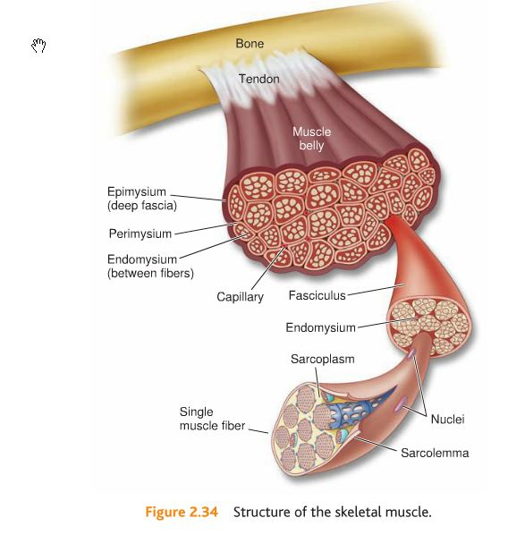
KNOW THIS FIGURE!
Muscle Fibers and their Contractile Elements
- Fibers are encased in a plasma membrane known as sarcolemma.
- Sarcomere – functional unit of muscle that produces muscular contraction and consists of repeating sections of actin and myosin.
- Neural Activation – Contraction of a muscle generated by neural stimulation.
- Motor Unit – Motor neuron and all of the muscle fibers it innervates.
- Neurotransmitters – Chemical messengers that cross the neuromuscular junction (synapse) to transmit electrical impulses from nerve to the muscle.
- Acetylcholine (ACh) is what is used by neuromuscular system. Once attached ACh stimulates fibers to go through a series of steps that initiates muscle contractions.
- Muscles are divided into motor units. Single motor unit consists of one motor neuron(nerve) and the muscle fibers it innervates. If stimulus is strong enough it will spread through whole length of muscle fiber, all of the muscle fibers supplied by a single nerve. If the stimulus is not strong enough then there will be no action potential and no muscle contraction. Motor units cannot vary the amount of force they generate. They either contract maximally or not at all.
- Because of all or nothing law the overall strength of skeletal muscle contraction depends on size of the motor unit recruited(how many muscle fibers are contained within the unit) and number of motor units activated.
- Muscles that control fine movements are made up of many small motor units. Large muscles are made up of larger motor units. 10-20 fibers in each eye motor unit. 2,000 to 3,000 fibers in intestinal motor units.
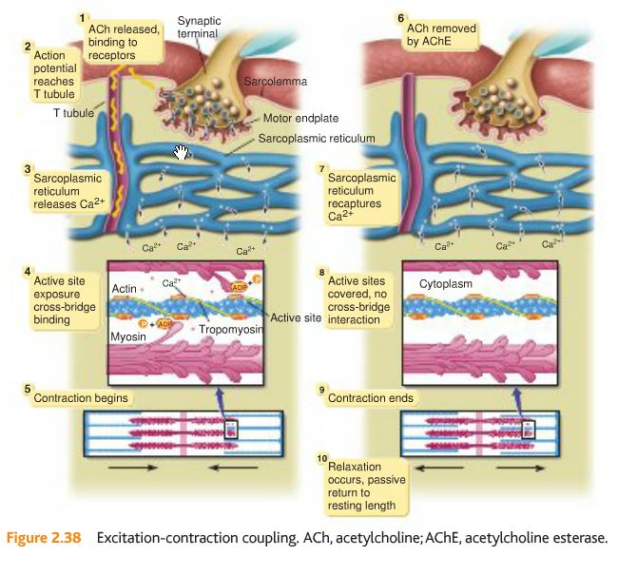
Understand this figure.
Muscle Fiber Types
- Fiber types vary in chemical and mechanical properties. Two main types, type I and type II.
- Type I(slow twitch) contain large number of capillaries, mitochondria(transforms energy from food into ATP), myoglobin(increased delivery of oxygen). Red fibers
- Type II(fast-twitch) subdivided into Type IIa and Type IIx. Contain fewer capillaries, mitochondria, and myoglobin. White fibers.
- Type IIx have low oxidative capacity and fatigue quickly.
- Type IIa higher oxidative capacity and fatigue more slowly than IIx. IIa are known as intermediate fast-twitch fibers.
- Type I are smaller in diameter, slow to produce maximal tension, more resistant to fatigue. Produce long term contractions. Think marathons. Maintaining posture against gravity.
- Type II larger in size, quick to produce maximal tension, fatigue more quickly. Sprint muscles.
- All muscles have combination of slow and fast twitch. Ex. shin has 735 slow twitch type I whereas calf muscle has 49% slow twitch.
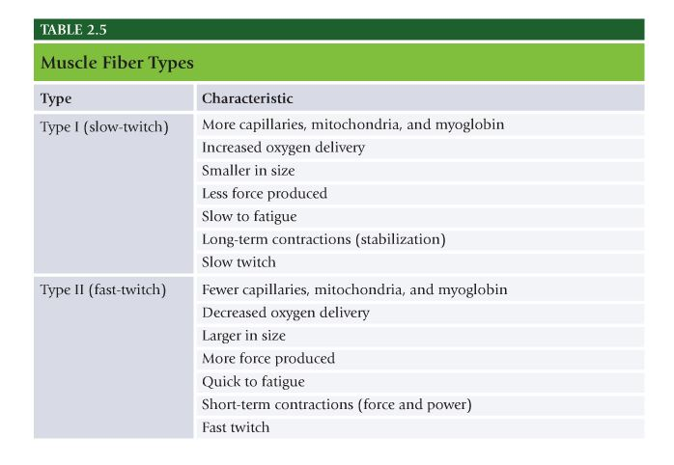
Know this.
Muscles as Movers
- Agonist muscles act as prime movers. They are most responsible for a particular movement.
- Synergist muscles assist prime movers. Synergist, think synergy. Assists with.
- Stabilizer support and stabilize the body.
- Antagonist muscles perform opposite action of prime mover.
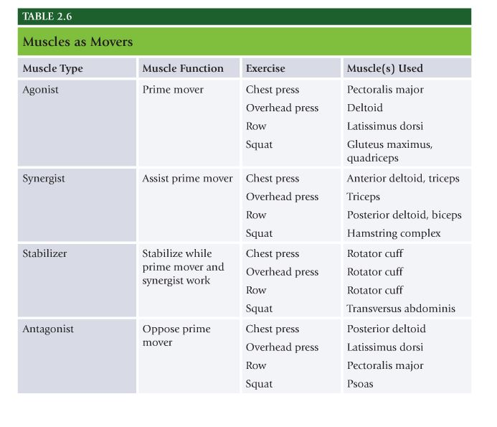
Know this figure for the test.
The Endocrine System
- System of glands that secrete hormones into bloodstream to regulate variety of bodily functions. Mood, growth, development, tissue function, and metabolism.

Endocrine Glands
- Primary endocrine glands are hypothalamus, pituitary, thyroid, and adrenal glands.
- Pituitary, “master” gland. Controls functions of other endocrine glands.
- Thyroid produces hormones that regulate metabolism and affect growth.
- Adrenal glands secret hormones – corticosteroids, catecholamines, cortisol, adrenaline in response to stress.
- Hormonal activity control rests with hypothalamus and pituitary gland.

Insulin, Glucagon, and Control of Blood Glucose
- Glucose is primary energy source during vigorous exercise. Glucose principal fuel for the brain. Too much glucose can damage vascular system. Control of glucose regulated by pancreas – producing insulin and glucagon.
- Insulin – Regulate energy and glucose metabolism. Glucose rich blood is circulated through pancreas, elevated levels of glucose trigger release of insulin. Circulating insulin binds with receptors in skeletal muscle and liver cells and cell membranes become more permeable to glucose. Glucose then diffuses from bloodstream into cell resulting in drop in blood glucose. Thus insulin causes fat, liver, muscle cells to take up glucose from the blood and store it as glycogen in liver and muscle.
- Glucagon – Opposite effect of insulin, functions to raise blood glucose by triggering release of glycogen stores from liver. Drop in circulating blood glucose triggers release of glucagon from pancreas.
- As activity levels increase the glucose uptake by cells increases. Increases insulin sensitivity in cells. Glucagon also increases helping maintain steady supply of glucose.

Adrenal, Pituitary, Reproductive, and Thyroid Hormones
- Catecholamines – two, epinephrine(adrenaline) and norepinephrine. Produced by adrenal glands(on top of each kidney). Help prepare body for activity. Fight or flight. Hypothalamus triggers adrenals to secrete epinephrine for fight.
- Epinephrine – increases heart rate and stroke volume, elevates blood glucose levels, redistributes blood to working tissues, opens up airways.
- Testosterone – produced in testes in males, ovaries and adrenal glands in females. Males produce up to 10x more. Fundamental role in growth and repair of tissue. Estrogen produced in ovaries in female and small amounts in adrenals in males.
- Cortisol – Catabolic hormone. Secreted by adrenals, serves to maintain high energy supply. Chronic cortisol can lead to significant breakdown of muscle tissue.
- Growth Hormone – Released from pituitary, regulated by hypothalamus. Stimulated by several factors: estrogen, testosterone, deep sleep, vigorous exercise. Primary anabolic hormone responsible for most of growth and development during childhood until puberty when primary sex hormones take over. Increases development of bone, muscle tissue, and protein synthesis. Increases fat burning and strengthens immune system.
- Thyroid gland located at base of the neck below thyroid cartilage(Adams apple). Releases hormones responsible for metabolism regulation.
- Testosterone and growth hormone levels increase after strength training and moderate to vigorous aerobic exercise.
- Prolonged bouts of endurance training or extremely intense training lowers testosterone levels while raising cortisol levels.

Chapter 3 The Cardiorespiratory System:
- Figure 3.3 Atria and Ventricles know the functions of the right and left atrium and the right and left ventricles
- Table 3.1 Support Mechanisms of Blood
- Table 3.2 Structures of the respiratory pump.

The Cardiovascular System
- Cardiorespiratory system – composed of cardiovascular and respiratory system.
- Cardiovascular system – Heart, blood, and blood vessels.

The Heart
- Heart – Hollow, muscular organ that pumps a circulation of blood through the body by means of rhythmic contraction. Positioned in thoracic cavity, lying anteriorly(in front) to the spine and posteriorly(behind) the sternum.
- Mediastinum – Space in the chest between lungs that contains all internal organs of the chest except lungs. Adult heart size of fist weighs 300g.
- Cardiac muscle one of three major types, involuntary muscle, not consciously controlled.
- Cardiac muscles are shorter and more tightly connected than skeletal muscle. Have irregularly spaced dark bands called intercalated discs.
- Sinoatrial (SA) Node – Specialized area of cardiac tissue located in the right atrium of the heart which initiates electrical impulses that determine the pacemaker for the heart. Electrical signals are transmitted from the SA, through both atria and down into ventricles. Referred to as the pacemaker for the heart.
- Atrioventricular (AV) Node – Small mass of specialized cardiac muscle fibers, located in the wall of the right atrium of the heart, that receives heartbeat impulses from the sinoatrial node and directs them to the walls of the ventricles. AV node delays electrical impulse from SA before allowing it to move on to ventricles. Directs impulses to walls of ventricles.
- Heart composed of four hollow chambers, delineated into two interdependent but separate pumps on each side. Two pumps are separated by interatrial septum(separates atria) and interventicular septum(separates the ventricles).
- Each side of the heart has two chambers, an atrium and a ventricle.
- Right side of the heart is the pulmonic side because it receives blood from the body that is low in O2 and high in CO2 and pumps it to the lungs then back to the left atria.
- Left side of heart is systemic side, pumps blood high in O2 low in CO2 to rest of the body.
- Blood pumped from right side, pulmonic, to the lungs, then through left side, systemic to the rest of the body. Right to left.
- Atria – Superior(upper) chamber of the heart that receives blood from veins and forces it into ventricles. On either side of heart. Gather blood returning to heart. Right atrium gathers deoxygenated blood, left atrium gathers oxygenated blood from lungs.
- Ventricles – Inferior(lower) chamber of the heart receives blood from its corresponding atrium and forces blood into arteries. Larger than atria. Right ventricle has thin walls and pumps under low pressure. Left ventricle has thicker walls and pumps under high pressure b/c it pumps blood out to the rest of the body. Right ventricle receives deoxygenated blood from right atrium, left ventricle receives oxygenated blood from left atrium.
- Each chamber of heart is separated from one another and major veins and arteries by valves to prevent backflow or spillage of blood.
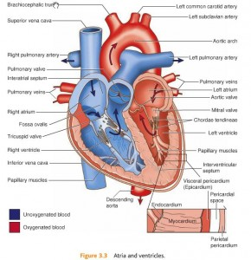
Know this figure for the test.
Functions of the Heart
- Stroke Volume – Amount of blood pumped out of the heart with each contraction. Difference between ventricular end-diastolic volume(EDV) and end-systolic volume(ESV). EDV is filled volume of ventricle before contraction, ESV is residual volume of blood remaining in ventricle after contraction. Typical EDV 120mL and ESV 50mL. Difference, 70mL represents SV. D comes before S EDV is BEFORE contraction, and ESV come AFTER contraction.
- Heart Rate – Rate at which heart pumps.
- Cardiac output (Q) – Heart rate x stroke volume, overall performance of heart.

Blood
- Blood – Fluid circulates in the heart, arteries, capillaries, and veins, carries nutrients and oxygen to all parts of the body and also rids body of waste products. Blood consists of cells suspended in watery liquid called plasma, which also contains nutrients such as glucose, hormones, and clotting agents.
- Red, white, and platelets in blood cells.
- Plasma makes up 55% of volume of blood and 45% are red, white, platelets. 4-6L of blood in adult.
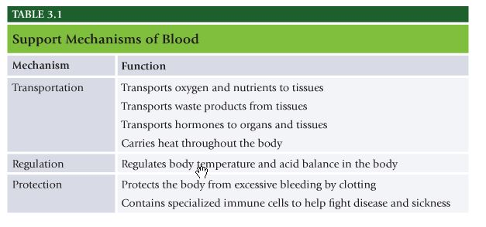
Know this for the test!
Blood Vessels
- Blood vessels – network of hollow tubes that circulates blood throughout body. Transported to and from heart.
- Arteries – Blood vessels that transport blood away from heart.
- Capillaries – Smallest blood vessels, site of exchange of chemicals and water between blood and tissue.
- Veins – Vessels that transport blood from capillaries toward the heart.
- Largest artery in the body is the aorta, carries blood away from the heart.
- Arterioles – small terminal branches of an artery which end in capillaries.
- Venules – Very small veins that connect capillaries to the larger veins.

The Respiratory System
- Respiratory System – Lungs and respiratory passageways that collect oxygen from external environment and transports it to bloodstream.
- Breathing is the process of moving air in and out of the body and requires optimal functioning of the respiratory pump and all its components.
- Respiratory Pump – Bones and soft tissue that work together to allow proper respiratory mechanics to occur and help pump blood back to heart during inspiration.
- Inspiration – Inhalation, actively contracting the inspiratory muscles to move air into body. Actively contracting.
- Expiration – Exhalation, process of actively or passively releasing inspiratory muscles to move air out of the body.
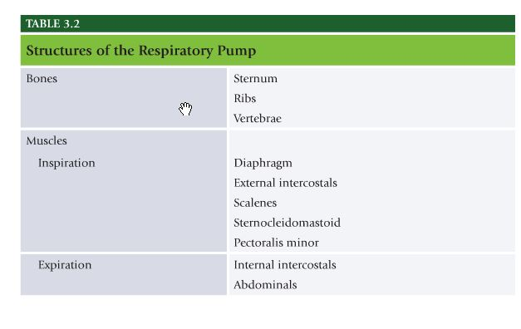
Know this table for the test.
Respiratory Airways
- Respiratory passages are divided into conducting airways and respiratory airways.
- Conducting airways consists of all structures that air travels through before entering respiratory airways. Nasal, oral cavities, mouth, pharynx, larynx, trachea, basically your nose and throat before lungs.
- Diffusion – process of getting oxygen from environment to tissues of the body.
Cardiorespiratory System Function
- Cardiovascular and respiratory systems work together to transport oxygen to body tissues. Capacity to efficiently use oxygen is dependent on respiratory system’s ability to collect oxygen and the cardiovascular system’s ability to absorb and transport it.
- Use of oxygen by the body is oxygen uptake.
- Resting oxygen consumption (VO2) is approximately 3.5 mL of oxygen per KG of bodyweight per minute, typically named 1 metabolic equivalent or 1 MET.
- Fick equation – equation for oxygen consumption.
- Maximal Oxygen Consumption (VO2max) – Highest rate of oxygen transport and utilization achieved at maximal physical exertion. Best measure of cardiorespiratory fitness. Anywhere from 11 to 23 METs.

Abnormal Breathing Patterns
- Breathing pattern becomes more shallow, uses secondary respiratory muscles more than diaphragm. Upper chest breathing becomes habitual causing overuse in secondary respiratory muscles such as scalenes, sternocleidomastoid, levator scapulae, and upper trapezius.
- Respiratory muscles also play major postural role in human movement system, all connecting directly to cervical and cranial portions of the body. Increased activity and excessive tension may result in headaches, lightheadedness, and dizziness.
- Excessive breathing(short, shallow) can lead to altered CO2 and Oxygen blood content and can lead to feelings of anxiety.
- Inadequate oxygen and retention of metabolic waste within muscles can create fatigued, stiff muscles.
- Inadequate joint motion of the spine and rib cage, as a result of improper breathing, causes joints to become restricted and stiff.

Chapter 4 Exercise Metabolism and Bioenergetics:
Be Familiar with all definitions throughout the chapter

Bioenergetics and Metabolism
- Bioenergetics – Study of energy in the human body.
- Metabolism – All of chemical reactions that occur in the body to maintain itself. Metabolism is process in which nutrients are acquired, transported, used, and disposed of by the body.
- Exercise Metabolism – Examination of bioenergetics as it relates to unique physiologic changes and demands placed on the body during exercise.

Fuel for Energy Metabolism
- Substrates – Material or substance on which enzyme acts. Proteins, carbs, fats are main substrates used to transfer metabolic energy to be used for all types of cellular activity and life.
- Carbohydrates – Organic compounds of carbon, hydrogen, oxygen which include starches, cellulose, and sugars. Important source of energy. All carbs broken down into glucose(simple sugar).
- Glucose – Absorbed and transported in the blood. Simple sugar manufactured from carbs, fat, and lesser extent protein.
- Glycogen – Complex carb molecule used to store carbs in liver and muscle cells. When carb energy is needed, glycogen is converted into glucose for use by muscle cells.
- Fat – Helps the body use vitamins and keep skin healthy, serve as energy stores for the body. Two types of fats in food saturated and unsaturated.
- Triglycerides – Chemical substrate form in which most fat exists in food as well as in the body.
- Protein – Amino acids linked by peptide bonds, which consist of carbon, hydrogen, nitrogen, oxygen, and usually sulfur. Protein rarely supplies much energy during exercise, ignored as significant fuel for energy metabolism. Protein becomes significant source of fuel during starvation.
- Gluconeogensis – Formation of glucose from noncarbohydrate sources, such as amino acids.

Energy and Muscle Contraction
- Adenosine Triphosphate – Energy storage and transfer unit within the cells of the body. When chemical bonds holding ATP are broken, energy is released for cellular work(such as muscle contraction), breaking the bond leaves behind molecule called adenosine diphosphate (ADP).
- Adenosine Diphosphate – High-energy compound occurring in all cells from which ATP is formed. Free energy is harnessed, used to attach phosphate group to an ADP and restore ATP levels back to normal to perform more work.
- Energy is used to form myosin-actin cross-bridges that facilitate muscle contraction. Cross-bridges is an enzyme that separates phosphate from ATP, releasing energy. Energy is needed to allow cross-bridge to ratchet thin actin filament toward center of sarcomere. Once that process is complete another ATP is needed. For one cycle of a cross-bridge two ATPs are needed.

Energy and Mechanical Work
- Any form of exercise can be defined by intensity and duration.
- 40% of energy released from ATP is actually used for cellular work, remainder is released as heat.
- ATP = ADP + Pi + Energy release
- Phosphorylation – process of adding phosphate group onto ADP to create ATP
- Three metabolic pathways cells can use to generate ATP – 1. ATP-PC system, 2. Glycolytic system(glycolysis), 3. Oxidative system(oxidative phosphorylation)
- ATP-PC System – Transfers phosphate group from another high energy molecule called phosphocreatine(PC or CP) to ADP molecule enough energy can be produced to facilitate one cross-bridge cycle. ATP and PC are called phosphagens. Creating new ATP from phosphocreatine molecule(ATP-PC system) is simplest and fastest way. Occurs without presence of oxygen(anaerobic). Only supplies energy for 10-15 secs before exhausted, this system is activated at onset of activity regardless of intensity.
- Glycolysis – The other anaerobic means of producing ATP. Chemical breakdown of glucose. Anaerobic glycolysis. Glucose or glycogen must be converted to glucose-6-phosphate before it can generate energy. Conversion of glucose to glucose-6-phosphate takes 1 ATP molecule, with glycogen it does not. Glucose and glycogen are broken down into pyruvic acid(aerobic glycolysis) or lactic acid(anaerobic glycolysis). 2 ATP for each mole or unit of glucose and 3ATP for each unit of glycogen. This system can produce significantly greater amount of energy than ATP-PC system, it too is limited to approximately 30 to 50 seconds of duration.
- Oxidative System – Most complex of three energy systems. Uses substrates with aid of oxygen to generate ATP. Three oxidative systems include aerobic glycolysis, krebs cycle, electron transport chain(ETC).
- B-oxidation – Breakdown of triglycerides into smaller subunits called free fatty acids(FFAs) to convert FFAs into acyl-CoA molecules, which then are available to enter the Krebs cycle and ultimately lead to the production of additional ATP.

Energy During Exercise
- Most important factor regulating energy utilization during exercise is the intensity and duration of exercise.
- After 90 mins of exercise majority of muscle glycogen stores are depleted.

Metabolism during Steady-State Exercise
- Excess Postexercise Oxygen Consumption(EPOC) – State in which the body’s metabolism is elevated after exercise. Energy demands fall back to baseline after exercise but oxygen consumption remains elevated for short period to keep generating ATP aerobically, this is the EPOC. ATP Above and beyond what is needed for recovery is produced to help reestablish baseline levels of ATP and PC and assist in clearing metabolic end products(like lactic acid).

Metabolism during Intermittent Work
- Most of energy comes from anaerobic metabolism. When intensity is decreased there is a continued period of high, but briefly elevated oxygen consumption. If high intensity work is short, fueled by ATP-PC, then recovery period if brief. Recovery of ATP-PC cycle is complete in 90 seconds. If period of high intensity work is longer recovery period will take longer.
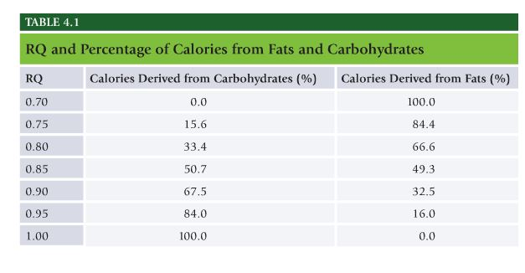
The Myth of the Fat Burning Zone
- Even though a RQ of .8 results in 67% of energy coming from fat and 33% from carbs, you’re only expending 4.8 cals per minute equaling 3.2 from fat. If you double intensity to RQ of .86, 54% of energy comes from fat. But 9.75 cals are expended per minute, thus more cals from fat are still expended even though fat burning % is lower.

NASM Study Guide Chapter 5 – Human Movement Science

Chapter 5 Human Movement Science:
- Know definitions throughout the chapter in detail.
- Figure 5.3 Planes of Motion
- Table 5.1 Examples of Planes, Motions, and Axes
The planes of motion can be a bit tricky, so here is a little bit of clarification:
Frontal Plane
- NOT front to back movements
- Side to side movements
- Exercises involving abduction and/or adduction of the limbs
- Example: side lunge, lateral dumbbell raise, ice skater
Imagine a wall in front and in back of you. The ONLY movement this would allow is along that plane-sideways movements.
Sagittal Plane
- Forward and backwards movements
- Movements involving pushing and/or pulling
- Movements involving flexion and/or extension at joints
- Example: bicep curl, front lunge, bench press, and rows
Imagine a wall on your right and left side. The ONLY movement this would allow is along that plane-or front and back movements.
Transverse Plane
- Rotational movements
- Diagonal movements
- Example: rotation, wood-chop throw, medicine ball rotation chest pass
- Figure 5.4 Joint Motions
- Figure 5.5 Joint Motions
- Figure 5.6 Joint Motions
- Figure 5.7 Joint Motions
- Table 5.2 Muscle Action Spectrum
- Isotonic
  - Eccentric
  - Concentric
- Isometric
- Isokinetic
- Table 5.3 Common force couples
- Figure 5.15 Levers

Biomechanics
Terminology
- Biomechanics – Science concerned with the internal and external forces acting on the human body and the effects produced by these forces.
- Superior – Positioned above a point of reference
- Inferior – Positioned below a point of reference
- Proximal – Positioned nearest the center of the body, or point of reference. – Knee more proximal to the hip the an ankle.
- Distal – Positioned farthest from the center of the body, or point of reference Ankle more distal to the hip than knee.
- Anterior (or Ventral) – On the front of the body On or forward, front of the body, quads are anterior on the thigh.
- Posterior (or Dorsal) – On the back of the body. Hamstring complex is posterior.
- Medial – Positioned near the middle of the body. Close to midline of the body. Adductors are medial side of thigh, side closest to midline of the body. Sternum more medial than shoulder.
- Lateral – Positioned on the outside of the body. Ears are on the lateral side of the head.
- Contralateral – Positioned on the opposite side of the body. Right foot is contralateral to the left hand.
- Ipsilateral – Positioned on the same side of the body. Right food is ipsilateral to right foot.

Planes of Motion, Axes, and Joint Motions
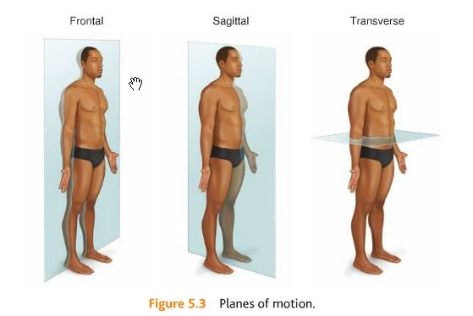
Know this for the test.
- Movement is said to occur more commonly on a specific plane if it is actually along the plane or parallel to it.
- Anatomic Position – Position with the body erect, arms at side, palms forward. Anatomic position is important in anatomy because it is the position reference for anatomic nomenclature. Anterior, posterior, medial, lateral apply to the body when it is in the anatomic position.
- Sagittal Plane – Bisects the body into left and right halves. Movements in sagittal plane include flexion and extension.
- Flexion – Bending movement in which the relative angle between two adjacent segments decreases.
- Extension – A straightening movement in which the relative angle between two adjacent segments increases.
- Hyperextension – Extension of joint beyond the normal limit or range of motion.
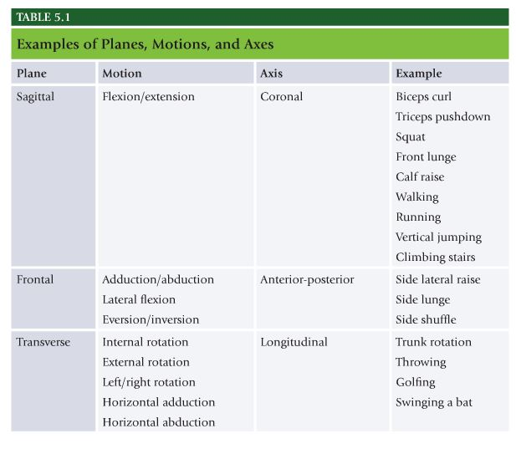
Know this table for the test.

The Frontal Plane
- Frontal Plane – Bisects the body into front and back halves.
- Abduction – Movement in frontal plane away from the midline of the body. Similar to extension, increase in the angle between two adjoining segments in the frontal plane. Side lat raises.
- Adduction – Movement in frontal plane back toward midline of the body.

Transverse Plane
- Transverse Plane – Imaginary bisector divides body into top and bottom halves. Upper and lower halve.
- Internal Rotation – Rotation of a joint toward the middle of the body.
- External rotation – Rotation of a joint away from the midline of the body.
- Horizontal Abduction – Movement of the arm or thigh in the transverse plane from an anterior position to a lateral position. Movement from a front position to aside position.
- Horizontal Adduction – Movement of the arm or thigh in the transverse plane from a lateral position to an anterior position. Side to front.

Scapular Motion
- Scapular Retraction – Adduction of scapula; shoulder blades move toward midline
- Scapular Protraction – Abduction of scapula; shoulder blades move away from midline.
- Scapular Depression – Downward(inferior) motion of the scapula.
- Scapular Elevation – Upward(superior) motion of the scapula.

Muscle Actions
- Three primary types of muscle actions: isotonic(eccentric and concentric), isometric, and isokinetic. Iso means same or equal. Tonic means tension. Metric means length. Kinetic means motion.
- Isotonic – constant muscle tension. Isometric – constant muscle length. Isokinetic – constant velocity of motion.

Isotonic
- Force is produced, muscle tension developed, movement occurs. Two components – eccentric and concentric phase.
- Eccentric – Muscle develops tension while lengthening. Synonymous with deceleration. Observed in many movements such as landing from a jump. Lowering the weight during resistance exercise. “negatives”.
- Concentric – Muscle is exerting force greater than resistive force, resulting in shortening of the muscle. Contractile force is greater than resistive force, shortening of muscle. The lifting portion of exercise.

Isometric
- Isometric – Muscle is exerting force equal to force being placed on it leading to no visible change in muscle length. Pause during resistance training. In sports, used to dynamically stabilize the body.
Isokinetic
- Isokinetic – Muscle shortens at a constant speed over the full range of motion. Harder individual pushes or pulls, more resistance they feel, requires expensive machinery. Usually only seen in rehab clinics.

Muscular Force
- Force – Influence applied by one object to another, which results in acceleration or deceleration of the second object. Characterized by magnitude(how much) and direction(which way).
- Length-Tension Relationship – Resting length of a muscle and the tension the muscle can produce at this resting length. Optimal muscle length is where acting and myosin filaments in the sarcomere have the greatest degree of overlap, this results in ability of myosin to make maximal amount of connections with actin and thus results in potential for maximal force production of that muscle. Lengthening a muscle beyond this optimal length and then stimulating it reduces the amount of actin and myosin overlap, reducing force production. Shortening muscle too much places actin and myosin in state of maximal overlap and allows for no further movement.
- If muscle lengths are altered, ex misaligned joints, then they will not generate the needed force to allow for efficient movement.
- Force velocity curve – relationship of muscle’s ability to produce tension at differing shortening velocities. As velocity of concentric muscle action increases, its ability to produce force decreases.
- Force couple – Muscle groups moving together to produce movement around a joint. Muscles in force couple provide divergent pulls on bone or bones they connect to, this is a result from the fact that each muscle has different attachment sites, pull at a different angle, and creates a different force on that joint.

Muscular Leverage and Arthrokinematics
- Levers are classified by first, second, and third class.
- First class levers have fulcrum in the middle, like a seesaw. Nodding the head is first class lever.
- Second-class levers have resistance in the middle(with fulcrum and effort on either side. Like a load in a wheelbarrow. Body acts as second class lever when engaged in pushup or calf raise. Calf raise ball of foot is fulcrum, bodyweight is resistance, effort is applied by calf musculature.
- Third-class levers have effort placed between resistance and fulcrum. Most limbs are operated as third class levers. Ex. forearm, fulcrum is elbow, effort applied by biceps muscle, and load is in the hand.
- Rotary Motion – Movement of bones around the joints.
- Torque – Force that produces rotation. Common unit of torque is newton-meter of Nm.
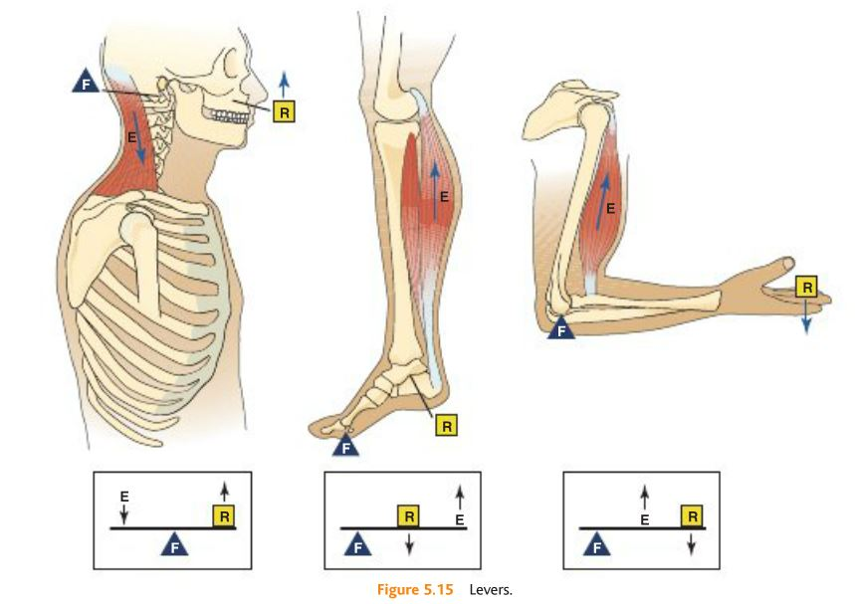
Know this for the test.

Motor Behavior
- Motor Behavior – Motor response to internal and external environmental stimuli. Manner in which nervous, skeletal, and muscular systems interact to produce skilled movement using sensory information from internal and external environments.
- Motor control – How the CNS integrates internal and external sensory information with previous experiences to produce a motor response. Learning from previous experiences.
- Motor learning – Integration of motor control processes through practice and experience, leading to relatively permanent change in capacity to produce skilled movements.
- Motor development – Change in motor skill behavior over time throughout the lifespan.

Motor Control
- Process of controlling neural, skeletal, and muscular components to produce movement is known as motor control. Focuses on the involved structures and mechanisms used by the CNS to integrate internal and external sensory information with previous experiences to produce skilled motor response.
- Muscle Synergies – Groups of muscles that are recruited by the central nervous system to provide movement.
- Proprioception – Cumulative sensory input to the CNS from all mechanoreceptors that sense body position and limb movement. Mechanoreceptors are the muscle spindle, Golgi tendon organ, and joint receptors.
- Sensorimotor Integration – Cooperation of the nervous and muscular system in gathering and interpreting information and executing movement. Nervous system ultimately dictates movement. Individuals training with improper form will develop improper sensory information, leading to movement compensations and potential injury.

Motor Learning
- Integration of motor control processes, with practice and experience, leading to a relatively permanent change in capacity to produce skilled movements.
- Feedback – Use of sensory information and sensorimotor integration to help the human movement system in motor learning.
- Internal feedback – process where sensory information is used by the body to reactively monitor movement and the environment. Length-tension relationships, force couple relations, and arthrokinematics. Internal feedback acts as a guide, steering HMS to proper force, speed, and amplitude of movement patterns.
- External Feedback – Info provided by external source, such as health and fitness professional, tape, mirror, HR monitor. Knowledge of results – feedback used after completion of movement to help inform client about outcome of his performance. “your squats were good” Knowledge of performance – feedback that provides information about quality of movement during exercise. Ex – Noticing feet externally rotated during squats, asking if client felt or saw anything different about those reps.

NASM Study Guide Chapter 6 – Fitness Assessment

Chapter 6 Fitness Assessment:
This is going to be a very important chapter to know as a lot of test question will be taken from this chapter.
- Table 6.1 Guidelines for Health and Fitness Professionals
- Figure 6.1 Subjective vs. Objective information
- Figure 6.2 Sample Physical Activity Readiness Questionnaire
- Figure 6.3 Sample questions: client occupation
- Figure 6.4 Sample questions: client lifestyle
- Figure 6.5 Sample questions: client medical history
- Table 6.2 Common medications by classification
- Table 6.3 Effects of medication on heart rate and blood pressure
- Heart rate and blood pressure assessments
- Table 6.4 Target heart rate training zones
- Max Heart Rate formula (straight percentage method) for each zone
- Body Composition Assessments
- Circumference measurements
- Body Mass Index
- YMCA 3-minute step test
- Rockport Walk Test
- Table 6.9 Pronation Distortion Syndrome
- Table 6.10Lower Crossed Syndrome
- Table 6.11Upper Crossed Syndrome
- Be familiar with all of the assessment protocols and for the posture assessments all compensations
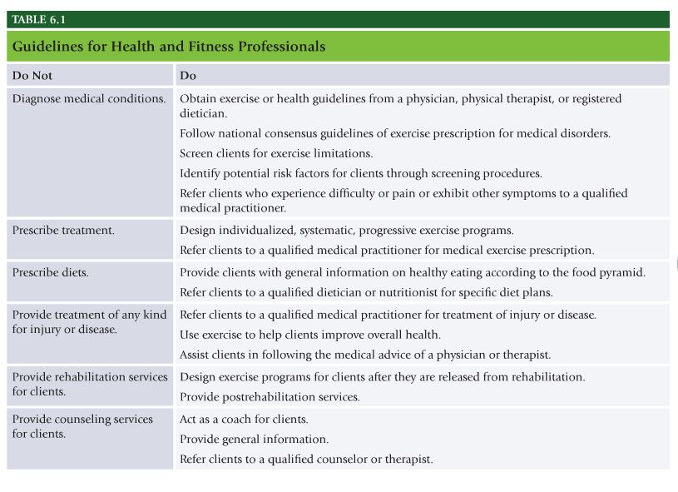
Know this for the test.
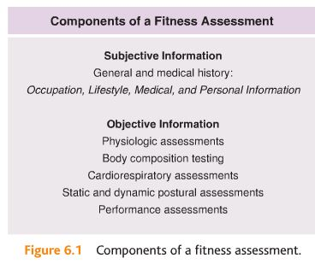
Know this for the test.

Subjective Information Provided in the Fitness Assessment
Preparticipation Health Screening
- Subjective information is gathered from a prospective client to give the personal trainer feedback regarding personal history – such as occupation, lifestyle, and medical background.
- Use medical history questionnaire and classify clients as:
- Low risk – No signs or symptoms of cardiovascular, pulmonary, or metabolic disease and have <1 cardiovascular risk factor.
- Moderate risk – Do not have signs or symptoms of cardiovascular, pulmonary, or metabolic disease but have >2 cardiovascular disease risk.
- High risk – One or more signs of cardiovascular, pulmonary, or metabolic disease
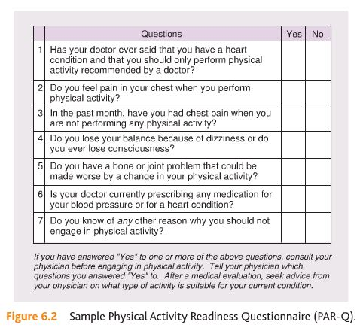
Know this for the test.

Physical Activity Readiness Questionnaire
- Designed to determine the safety or possible risk of exercising for a client based on answers to specific health history questions.
- Aimed at identifying individuals who require further medical evaluation before being allowed to exercise.
- When client answers yes to one or more questions then PT should refer client to physician.

General Health History
- Health History is collection of info that is generally part of medical physical or medical health history, discusses relevant facts about individual’s history, including biographic, demographic, occupational, and lifestyle.
- Focus on answers for occupation and general lifestyle traits.
- Occupation – determine common movement patterns, as well as typical energy expenditure levels.
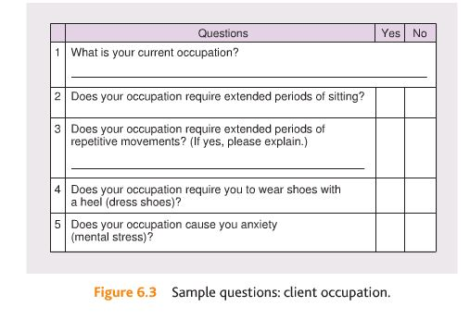
- Extended periods of sitting means hips are flexed for long periods of time, lead to tight hip flexors and postural imbalances. Tendency for shoulders and head to fatigue, lead to postural imbalances including rounding of shoulders and a forward head.
- Repetitive movements can create pattern overload to muscles and joints. Working with arms overhead for long periods may lead to shoulder and neck soreness and tightness of lats and weakness in rotator cuff.
- Dress shoes put ankle complex in plantarflexed positions for long periods, lead to tightness in gastrocnemius, soleus, and Achilles’ tendon, causing postural imbalance such as decreased dorsiflexion and over pronation of foot and ankle complex, resulting in flattening of the arch of the foot.
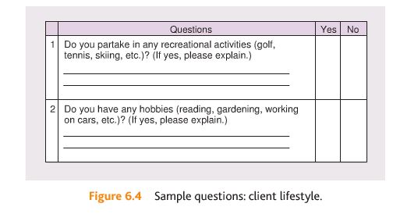

- Mental stress can elevate resting heart rate, blood pressure, and ventilation at rest and exercise. Lead to abnormal breathing patterns that may cause postural or musculoskeletal imbalances in the neck, shoulder, chest, and low-back muscles.

Medical History
- Vitally important because it provides PTs with info about known or suspected chronic diseases, such as coronary heart disease, high blood pressure, or diabetes.
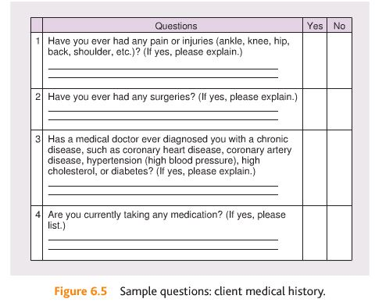

Past Injuries
- All past or recent injuries should be recorded and discussed in sufficient detail to be able to make decisions about whether exercise is recommended or medical referral is necessary.
- Previous history of musculoskeletal injury is also strong predictor of future musculoskeletal injury during physical activity.
- Ankle sprains – decrease neural control of glueteus medius and gluteus maximus muscles, in turn lead to poor control of lower extremities during many functional activities, which can eventually lead to injury.
- Knee injuries involving ligaments: Knee injury can cause decrease in neural control to muscles that stabilize the patella(kneecap) and lead to further injury. Knee injuries that are not result of contact are often result of ankle or hip dysfunctions, such as result of ankle sprain.
- Low-back injuries – cause decreased neural control to stabilizing muscles of the core, resulting in poor stabilization of the spine. Can lead to further dysfunction in the upper and lower extremities.
- Shoulder injuries – cause altered neural control of rotator cuff muscles, which can lead to instability of shoulder joint during functional activities.

Past Surgeries
- Surgical procedures create trauma for body. Surgery will cause pain and inflammation that can alter neural control to affected muscles and joints if not rehabilitated properly.

Chronic Conditions
- Estimated more than 75% of American adult population does not engage in at least 30 minutes of low-to-moderate.
- Chronic conditions – cardiovascular disease, hypertension(high blood pressure), high cholesterol, stroke, peripheral artery disease, lung or breathing problems, obesity, diabetes, cancer.
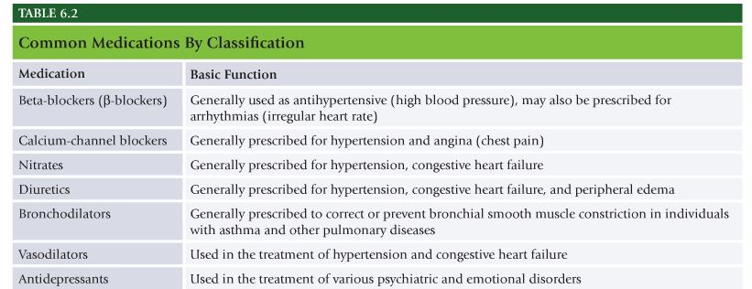

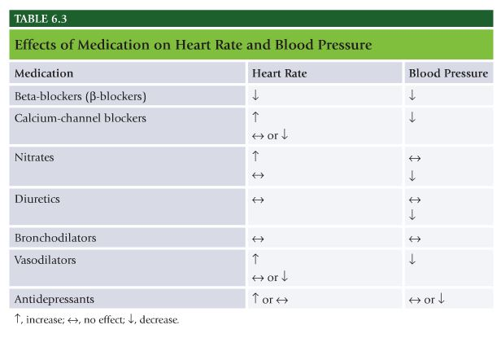

Objective Information Provided in Fitness Assessment
- Physiological measurements
- Body composition assessments
- Cardiorespiratory assessments
- Static posture assessment
- Movement assessments
- Performance assessments

Heart Rate and Blood Pressure Assessment
- Resting heart rate and BP is sensitive indicator of client’s overall cardiorespiratory health as well as fitness status. Resting HR is fairly good indicator of overall cardiorespiratory fitness, where as exercise HR is strong indicator of how a client’s cardiorespiratory system is responding and adapting to exercise.
- Pulse – Most common sites used are radial and carotid arteries.
- Preferred to record HR with radial(inside wrist).
- Instruct clients to rise three mornings in a row and test resting HR, average those 3 readings.
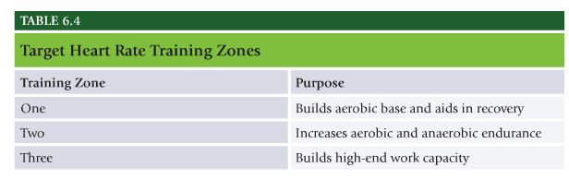
Calculating Target Heart Rate
Straight Percent Method
- Straight Percentage Method – Subtracting age from 220 = MAX HR. Multiply HRmax by appropriate intensity(65 to 95%).
- Zone one – HRmax X .65 to .75
- Zone two – HRmax X .76 to .85
- Zone three – HRmax X .86 to .95

Heart Rate Reserve Method(HRR)
- Karvonen method, method of establishing training intensity on the basis of difference between a client’s predicted maximal HR and their resting HR.
- HR and oxygen uptake are linearly related during exercise, selecting predetermined training or THR based on given percent of oxygen consumption is most common and universally accepted method of establishing exercise training intensity.
- HRR is: THR = [(HRmax – HRrest) x desired intensity] + HRrest

Blood Pressure
- BP is pressure of the circulating blood against the walls of the blood vessels after blood is ejected from the heart. Two parts of a blood pressure measurement. First(top) is systolic, represents pressure within arterial system after heart contracts. Second(bottom) is diastolic, and it represents pressure within arterial system when heart is resting and filling with blood.
- Ex. 120/80 120 systolic 80 diastolic.
- Acceptable systolic is less than 120 and acceptable diastolic is less than 80.
- Instruct client to assume comfortable position, place appropriate cuff on clients arm just above elbow. Inflate cuff to 20-30mm Hg above point at which pulse can no longer be felt. Release pressure at a rate of 2mm Hg per second, listening for pulse. Systolic pressure is first observation of pulse, diastolic is determined when pulse fades away. For greater reliability repeat on opposite arm.

Body Composition
- Refers to relative percentage of body weight that is fat versus fat-free tissue. Fat free mass includes muscles, bones, water, connective and organ tissues. Fat is essential and nonessential(adipose tissue).
- Skinfold measurement – uses calipers
- Bioelectrical impedance – portable instrument to conduct electrical current through body to estimate fat. Hypothesis that tissues that are higher in water conduct electrical currents with less resistance than those with little water(like adipose tissue).
- Underwater weighing – hydrostatic weighing, most common technique. Because bone and muscle are denser than water, person with larger percentage of lean body mass will weigh more in the water.

Skinfold Measurements
- Train with individual skilled in SKF and frequently compare results
- Take minimum of two measurements at each site, each site must be within 1 to 2mm to take average at each site.
- Open jaw of caliber before removing from site.
- Be meticulous when locating anatomic landmarks.
- Do not measure SKFs immediately after exercise.
- Instruct clients ahead of time regarding test protocol.
- Avoid performing SKFs on extremely obese clients.

Calculating Body Fat Percentage
- NASM uses Durnin formula to calculate client’s percentage of body fat. Four site skinfold measurement.
- Biceps – Vertical fold on front of the arm over biceps muscle, halfway between shoulder and elbow.
- Triceps – vertical fold on back of upper arm, with arm relaxed and held freely at the side, skin fold taken halfway between shoulder and elbow
- Subscapular – 45 degree angle fold or 1 to 2cm, below inferior angle of scapula.
- Iliac crest – 45 degree angle fold, taken just above iliac crest and medial to the axillary line.
- All skinfold measurements should be taken on the right side of the body. After four sites have been measured, add totals of four sites, find appropriate sex and age category.

Circumference Measurements
- Measure of the girth of body segments(arm, thigh, waist, and hip)
- Affected by both fat and muscle, does not provide accurate estimate of fatness in general pop.
- Some uses: can be used on obese clients, good for comparisons and progressions, good for assessing fat pattern and distribution, inexpensive, easy to record
- Neck – across Adam’s apple
- Chest – across nipple line
- Waist – narrowest point of waist, below rib cage, above top of hip bones
- Hips – feet together, circumference at widest portion of buttocks
- Thighs – measure 10 inches above top of patella(knee bone)
- Calves – At maximal circumference between ankle and knee
- Biceps – Maximal circumference of biceps, measure with arm extended, palm facing forward

Waist to Hip Ratio
- Most used clinical applications of girth measurements. Important because correlation between chronic diseases and fat stored in midsection.
- Waist to hip ratio can be computed by dividing waist measurement by the hip measurement.

Body Mass Index
- Rough assessment based on concept that a person’s weight should be proportional to their height.
- BMI = Weight(kg) / Height (m^2)
- BMI = [Weight(lbs)/Height (inch^2)]x703
- Lowest risk for disease lies within BMI range of 22 to 24.9

Cardiorespiratory Assessments
YMCA 3-Minute Step Test
- Designed to estimate individual’s cardiorespiratory fitness level on the basis of a submaximal bout of stair climbing at a set pace for 3 minutes.
- Step one – perform 3-minute step test by having client perform 24 steps per minute on 12 inch step for total of 3 minutes, roughly 96 steps total. Important that client performs steps with correct cadence.
- Step two – Within 5 seconds of completing exercise, client’s resting heart rate is measured for period of 60 seconds and recorded as recovery pulse.
- Step three – locate recovery pulse number in one of following categories.
- Step four – determine appropriate starting program using appropriate category. Poor Zone one(65-75%), Fair Zone one(65-75%), Average Zone Two(76-85%), Good Zone two(76-85%), Very good zone three(86-95%)
- Step five – determine client’s maximal heart rate by subtracting client’s age from the number 220 (220-age), then take maximal heart rate and multiply by zones to determine heart rate ranges for each zone.

Rockport Walk Test
- Designed to estimate cardiovascular starting point. Starting point is then modified baed on ability level.
- Step one – Record client’s weight. Have client walk one mile, as fast as he or she can control, on treadmill. Record time. Immediately record client’s heart rate at the 1 mile mark.
- Weight in lbs, gender male = 1, female = 0, time expressed in minutes and 100th of minutes, HR is beats per minute, age is years.

Posture and Movement Assessments
Importance of Posture
- Neuromuscular efficiency is ability of nervous system and musculature system to communicate properly producing optimal movement. Proper postural alignment allows optimal neuromuscular efficiency, helps produce effective and safe movement.
- Proper posture ensures muscles of the body are aligned at the proper length-tension relationships necessary for efficient functioning of force-couples. Proper posture will keep muscles at proper length, allowing muscles to properly work together, ensuring proper joint motion, maximizing force production, and reducing risk of injury.
- Static posture – how individual physically presents himself can be considered base from which an individual moves. Reflected int he alignment of the body.
- Janda identified three basic compensatory patterns. Suggested cascading effect of alterations or deviations in static posture that could more likely than not present themselves in a particular pattern.
- Pronation distortion syndrome – postural distortion syndrome characterized by foot pronation(flat feet) and adducted and internally rotated knees(knock knees)
- Lower crossed syndrome – postural distortion syndrome characterized by anterior tilt to the pelvis(arched lower back)
- Upper crossed syndrome – postural distortion syndrome characterized by a forward head and rounded shoulders
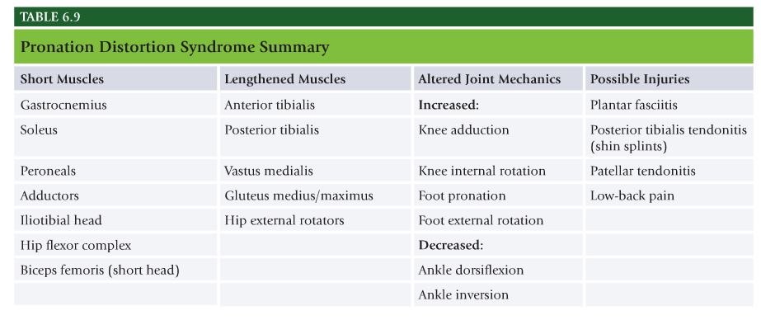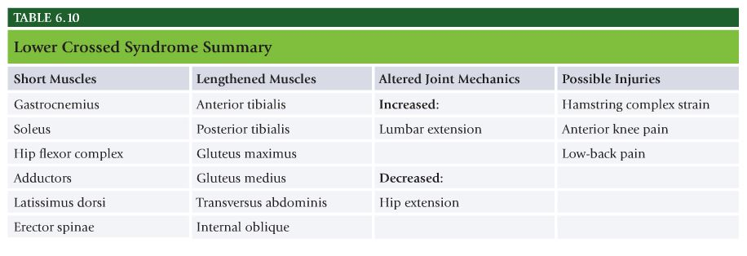
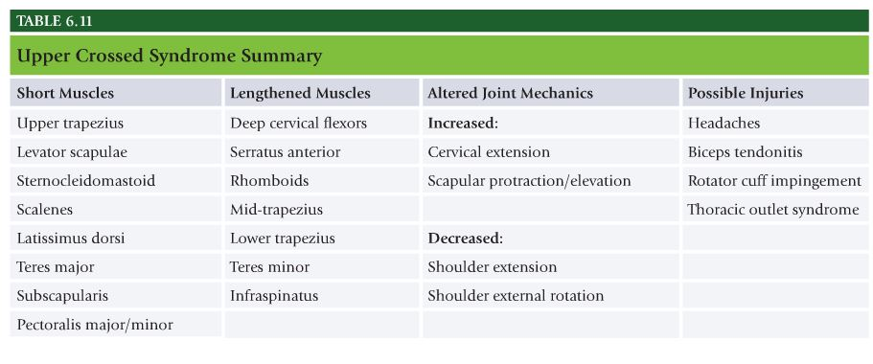

Static Postural Assessment
- One should be checking for neutral alignment, symmetry, balanced muscle tone, and specific postural deformities.
- Kinetic chain checkpoints refer to major joint regions of the body including – Foot and ankle, knee, lumbo-pelvic-hip complex (LPHC), shoulders, head and cervical spine
- Anterior View:
  - Foot/ankles – straight and parallel, not flattened or externally rotated
  - Knees – In line with toes, not adducted or abducted
  - LPHC – Pelvis level with both posterior superior iliac spines in same transverse plane
  - Shoulders – Level, not elevated or rounded
  - Head – Neutral position, not tilted or rotated
- Lateral View:
  - Foot/ankle – Neutral position, leg vertical at right angle to sole of foot
  - Knees – Neutral position, not flexed nor hyperextended
  - LPHC – Pelvis neutral position, not anteriorly (lumbar extension) or posteriorly (lumbar flexion) rotated
  - Shoulders – Normal kyphotic curve, not excessively rounded
  - Head – Neutral position, not in excessive extension (jutting forward)
- Posterior View
  - Foot/ankle – Heels are straight and parallel, not overly pronated
  - Knees – Neutral position, not adducted or abducted
  - LPHC – Pelvis is level with both posterior superior iliac spines and in same transverse plane
  - Shoulders/scapulae – Level, not elevated or protracted
  - Head – Neutral position, neither tilted nor rotated

Overhead Squat Assessment
- Designed to assess dynamic flexibility, core strength, balance, and overall neuromuscular control. Shown to reflect lower extremity movement patterns during jump-landing tasks. Knee valgus(knock-knees) during overhead squat test is influenced by decreased hip abductor and hip external rotation strength, increased hip adductor activity, and restricted ankle dorsiflexion.
- 1. Client stands with feet shoulders width apart and pointed straight ahead. Foot and ankle complex should be in a neutral position. Assessment performed with shoes off to better view foot and ankle complex.
- 2. Have client raise his or her arms overhead, with elbows fully extended.
- Movement – Instruct client to squat roughly to height of chair seat and return to starting position. 2. Repeat movement for 5 reps, observe from each position(anterior and lateral)
- Views – View feet, ankles, and knees from front. Feet should remain straight with knees tracking in line with foot. View lumbo-pelvic-hip complex, shoulder, and cervical complex from side. Tibia should remain in line with torso while arms also stay in line with torso.
- Compensations Anterior View – Feet, do feet flatten and/or turn out? Knees, do knees move inward(adduct and internally rotate)
- Compensations Lateral View – Lumbo-pelvic-hip complex – does the low back arch? Does the torso lean forward excessively? Shoulders: do the arms fall forward?

Single Leg Squat Assessment
- Transitional movement assessment also assesses dynamic flexibility, core strength, balance, and overall neuromuscular control.
- Reliable and valid measure of lower extremity movement patterns when standard application protocols are applied.
- Position – Client should stand with hands on hips and eyes focused on object straight ahead. Foot should be pointed straight ahead, and foot, ankle, and knee and lumbo-pelvic-hip complex should be in neutral position
- Movement – Have client squat to a comfortable level and return to starting position. Perform up to 5 repetitions before switching sides.
- Views – View knee from the front. Knee should track in line with the foot.
- Compensation – Does knee move inward(adduct and internally rotate?)

Pushing Assessment
- Like overhead and single leg squat assessments, this assesses efficiency and potential muscle imbalances during pushing movements.
- Position – Instruct client to stand with abdomen drawn inward, feet in a split stance and toes pointing forward
- Movement – Viewing from the side, instruct client to press handles forward and return to the starting position. Perform up to 20 repetitions in a controlled fashion. Lumbar and cervical spines should remain neutral while shoulders stay level.
- Compensations – Low back – does low back arch? Shoulders – do the shoulders elevate? Head – does the head migrate forward?

Pulling Assessment
- To assess movement efficiency and potential muscle imbalances during pulling movements
- Position – Stand with abdomen drawn inward, feet shoulders-width apart and toes pointing forward
- Movement – Viewing from side, instruct client to pull handles toward the body and return to starting position. Like pushing assessment lumbar and cervical spines should remain neutral while shoulders stay level.
- Compensations – Low back – does low back arch? Shoulders – Do shoulders elevate? Head – Does head migrate forward?

Davies Test
- Measures upper extremity agility and stabilization.
- Two pieces of tape, 36 inches apart. Client assumes push-up position. Alternating touch on each side for 15 seconds.

NASM Study Guide Chapter 7 – Flexibility Training Concepts

Chapter 7 Flexibility Training Concepts:
Know all definitions throughout the chapter
- Figure 7.10 Integrated flexibility Continuum
- Table 7.2 Examples of stretching within the Flexibility Continuum
- Myofascial Release
- Table 7.3 Static Stretching Summary
- Table 7.4 Active-Isolated Stretching summary
- Table 7.5 Dynamic Stretching summary

Mechanoreceptors = a Golgi tendon organ (GTO) and muscle spindle fibers
GTO | Muscle Spindle Fibers
Senses muscle tension | Senses muscle lengthening
Relaxes the muscle in response | Contracts the muscle in response
Normal reaction to avoid injury | Normal reaction to avoid injury
There is a lot of useful information page 183 of the NASM Essentials of Personal Fitness Training and it will take some time to remember all of that information. There are various strategies you can try as you attempt to retain that information. One is to make your studying interactive by asking friends and family members to volunteer for the Overhead Squat Assessment and practice trying to locate compensations. Another way to learn the probable overactive and probable underactive muscles is by creating flash cards.
You can also look at each overactive muscle and refer back to Appendix D (pages 575-596). Look at each muscle’s “Isolated Function”. Some muscles will over-do their “Isolated Function”. Other muscles tend to be “victims of association”. This means that they may become synergistically dominant because a muscle nearby becomes underactive/lengthened/weak.
In addition, by having a general idea of what each muscle’s “Isolated Function” is, you will be able to figure out exercises that directly work those muscles.
Think of muscles in terms of antagonistic (one is an agonist while the other is an antagonist) actions. When an agonist contracts, the antagonist will relax. Also keep in mind that several muscles may have similar actions and that the exact movement of a bone will be the result of a coordinated effort involving many muscles (force couples). Muscles function in integrated groups to allow for neuromuscular control during movement. A muscle’s integrated muscle function is the action it naturally tends to perform when it works in conjunction with other muscles. By isolating each muscle on the other hand, and tracing them from their point of origin to their insertion, one can gain a better understanding of that muscle’s main function. A muscle’s isolated function is what that individual muscle is meant to do, alone, and isolated from all other muscles.
An advanced knowledge in anatomy is required to identify muscle functions such as agonists, antagonists, synergists, and stabilizers. For example, most stabilizers are proximal to the joint they stabilize, but it is dependent on the movement that is occurring. Stabilizers are generally smaller in size, made up of type I muscle fibers (slow twitch), and they are prone to weakness.
Some examples of stabilizers include (1) rotator cuff – shoulder (2) core inner unit – multifidus, transverse abdominus, pelvic floor muscles, internal oblique – stabilize pelvis and spine (3) knee- VMO, popliteus – knee. For the exam you only need an understanding of this concept to the degree the textbook discusses. If you want to learn more, then the CES does a good job explaining these concepts in more detail.

Current Concepts in Flexibility Training
- Flexibility – Normal extensibility of all soft tissues that allows the full range of motion of a joint.
- Extensibility – Capability to be elongated or stretched.
- Dynamic range of motion – Combination of flexibility and the nervous system’s ability to control this range of motion efficiently.
- Neuromuscular efficiency – Ability of neuromuscular system to allow agonists, antagonists, and stabilizers to work synergistically to produce, reduce, and dynamically stabilize the entire kinetic chain in all three planes of motion. Ability of nervous system to recruit correct muscles(agonists, antagonists, synergists, stabilizers) to produce force, reduce force, and dynamically stabilize body’s structure in all three planes of motion. When performing cable pull down, latissimus dorsi(agonist) must concentrically accelerate shoulder extension, adduction, and internal rotation while middle and lower trapezius and rhomboids(synergists) perform downward rotation of the scapulae. Same time rotator cuff musculature(stabilizers) must dynamically stabilize the glenohumeral(shoulder) joint throughout the motion.
- To allow for optimal neuromuscular efficiency, individuals must have proper flexibility in all three planes of motion.

Review of Human Movement System
- Postural distortion pattern – Predictable patterns of muscle imbalances.
- Relative Flexibility – The tendency of the body to seek the path of least resistance during functional movement patterns. Prime example are people who squat with feet externally rotated, because of tight calf muscles they lack proper dorsiflexion at the ankle to perform squat with proper mechanics. Another example is overhead press with excessive lumbar extension(arched lower back). Individuals who possess tight latissimus dorsi will have decreased sagittal-plane shoulder flexion (inability to lift arms directly overhead), and as a result they compensate for this lack of ROM at shoulder in lumbar spine to allow them to press load completely overhead.

Muscle Imbalance
- Muscle imbalances – Alteration of muscle length surrounding a joint.
- Muscle imbalances can be caused by – postural stress, emotional duress, repetitive movement, cumulative trauma, poor training technique, lack of core strength, lack of neuromuscular efficiency
- Reciprocal Inhibition – simultaneous relaxation of one muscle and the contraction of its antagonist to allow movement to take place. To perform elbow flexion during biceps curl, biceps brachii actively contracts while triceps brachii(antagonist) relaxes to allow the movement to occur.
- Altered reciprocal inhibition – Concept of muscle inhibition, caused by tight agonist, which inhibits its functional antagonist. Example tight psoas(hip flexor) would decrease neural drive of the gluteus maximus (hip extensor). Altered reciprocal inhibition alters force-couple relationships, produces synergistic dominance, and leads to the development of faulty movement patterns, poor neuromuscular control, and arthrokinetic (joint) dysfunction.
- Synergistic Dominance – Neuromuscular phenomenon that occurs when inappropriate muscles take over the function of a weak or inhibited prime mover. Example if psoas(hip flexor) is tight, leads to reciprocal inhibition of gluteus maximus, which in turn results in increased force output of synergists for hip extension (hamstring complex, adductor magnus) to compensate for weakened glutes. The result of synergistic dominance is faulty movement patterns, leading to arthrokinetic dysfunction and eventual injury(such as hamstring strains).
- Arthrokinematics – Motion of joints in the body.
- Arthrokinematic dysfunction – Altered forces at the joint that result in abnormal muscular activity and impaired neuromuscular communication at the joint. Altered joint motion can be caused by altered length-tension relationships and force-couple relationships, which affect joint and cause poor movement efficiency. Example, squatting with externally rotated feet(outward) forces tibia(shin bone) and femur(thigh bone) to also rotate externally. This posture alters length-tension relationships of muscles at the knee and hips, putting glutes in a shortened position and decreasing its ability to generate force. Further, biceps femoris(hamstring muscle) and piriformis(outer hip muscle) become synergistically dominant, altering the force-couple relationships and ideal joint motion, increasing the stress on the knees and low back. With time, stress associated with arthrokinematic dysfunction can lead to pain, which can further alter muscle recruitment and joint mechanics.

Neuromuscular Efficiency
- Neuromuscular efficiency, ability of neuromuscular system to properly recruit muscles to produce force(concentric), reduce force(eccentric), and dynamically stabilize(isometric) the entire kinetic chain in all three planes of motion. Because nervous system is controlling factor behind this principle, it is important to mention that mechanoreceptors(sensory receptors) located in the muscles and tendons help to determine muscle balance or imbalance. Mechanoreceptors include muscle spindles and Golgi tendon organs.

Muscle Spindles
- Muscle spindles are the major sensory organ of the muscle and are composed of microscopic fibers that lie parallel to the muscle fiber. Muscle spindles are sensitive to change in muscle length and rate of length change. Muscle spindle’s job is to help prevent muscles from stretching too far or too fast.
- When a muscle on one side of a joint is lengthened(because of a shortened muscle on the opposite side), the spindles of the lengthened muscle are stretched. This information is transmitted to brain and spinal cord, exciting the muscle spindle and causing the muscle fibers of the lengthened muscle to contract. This often results in microspasms or feelings of tightness.
- Hamstring complex is prime example when pelvis is rotated anteriorly, meaning the anterior superior iliac spines(front of the pelvis) move downward(inferiorly) and the ischium(bottom posterior portion of pelvis, where the hamstrings originate) moves upward(superiorly). If attachment of hamstring complex is moved superiorly, it increases the distance between the two attachment sites and lengthens the hamstring complex. When a lengthened muscle is stretched, it increases the excitement of the muscle spindles and further creates a contraction(spasm) response. With this scenario, the shortened hip flexors are helping to create the anterior pelvic rotation that is causing the lengthening of the hamstring complex. Instead, hip flexors need to be stretched.
- Another example is individual whose knees adduct and internally rotate(knock-knees) during a squat. The underactive muscle is the gluteus medius(hip abductor and external rotator), and the overactive muscles include adductors(inner thighs) and tensor fascia latae(hip flexor and hip internal rotator). Thus, one would not need to stretch the gluteus medius, but instead stretch the adductor complex and tensor fascia latae which in this case are overactive, pulling the femur into excessive adduction and internal rotation.

Golgi Tendon Organs
- Autogenic Inhibition – Process by which neural impulses that sense tension are greater than the impulses that cause muscles to contract, providing an inhibitory effect to the muscle spindles.
- Golgi Tendon Organs are located within musculotendinous junction(point where muscle and tendon meet) and are sensitive to changes in muscular tension and rate of tension change. When excited, Golgi tendon organ causes the muscle to relax, which prevents muscle from being placed under excessive stress, which could result in injury. Prolonged Golgi tendon organ stimulation provides an inhibitory action to muscle spindles(located within same muscle). This neuromuscular phenomenon is called autogenic inhibition. Occurs when neural impulses sensing tension are greater than impulses causing contraction. This phenomenon is termed autogenic, inhibited by its own receptors.

Scientific Rationale for Flexibility Training
- Flexibility training is key component of all training programs, used for variety of reasons including – correcting muscle imbalances, increasing joint range of motion, decreasing the excessive tension of muscles, relieving joint stress, improving extensibility of musculotendinous junction, improving neuromuscular efficiency, improving function
- Pattern Overload – Consistently repeating same pattern of motion, which may place abnormal stresses on the body. Pattern overload is consistently repeating same pattern, such as baseball pitching, long-distance running, and cycling, with time places abnormal stresses on the body.

Cumulative Injury Cycle
- Poor posture and repetitive movements create dysfunction within the connective tissue of the body. This dysfunction is treated by body as another injury, and as a result, body will initiate repair process termed cumulative injury cycle.
- Any trauma to tissue of the body creates inflammation. Inflammation, in turn, activates body’s pain receptors and initiates protective mechanism, increasing muscle tension or causing muscle spasm. Heightened activity of muscle spindles in particular areas of muscle create a microspasm, and as result of spasm, adhesions(or knots) being to form in the soft tissue. These adhesions form a weak, inelastic matrix(inability to stretch) that decreases normal elasticity of the soft tissue, resulting in altered length-tension relationships(leading to altered reciprocal inhibition), altered force-couple relationships, and arthrokinetic dysfunction(leading to altered joint motion). Left untreated adhesions can begin to form permanent structural changes in soft tissue that is evident in Davis’s law.
- Davis’s Law – Soft tissue models along the lines of stress. Soft tissue is remodeled (or rebuilt) with inelastic collagen matrix that forms in a random fashion, usually it does not run in same direction as the muscle fibers. If muscle fibers are lengthened, these inelastic connective tissue fibers act as roadblocks, preventing muscle from moving properly which creates alterations in normal tissue extensibility and causes relative flexibility.
- If a muscle is in a constant shortened state(such as hip flexor musculature when sitting for prolonged periods every day), it will demonstrate poor neuromuscular efficiency(as a result of altered length-tension and force-couple relationships). In turn this will affect joint motion(ankle, knee, hip, and lumbar spine) and alter movement patterns(leading to synergistic dominance). Inelastic collagen matrix will form along the same lines of stress created by the altered muscle movements. Because the muscle is consistently short and moves in a pattern different from its intended function, the newly formed inelastic connective tissue forms along this altered pattern, reducing the ability of the muscle to extend and move in its proper manner. This is why it is imperative that an integrated flexibility training program be used to restore the normal extensibility of the entire soft tissue complex.

The Flexibility Continuum
- Three types of flexibility continuum, corrective, active, and functional.

Corrective flexibility
- Corrective flexibility is designed to increase joint ROM, improve muscle imbalances, and correct altered joint motion. Corrective flexibility includes self-myofascial release(foam roll) techniques and static stretching. Self-myofascial release uses the principle of autogenic inhibition to cause muscle relaxation, whereas static stretching can use either autogenic inhibition or reciprocal inhibition to increase muscle length depending on how the stretch is performed. Corrective flexibility is appropriate at the stabilization level (phase I) of the OPT model.

Active Flexibility
- Active flexibility uses self-myofascial release and active-isolated stretching techniques. Active-isolated stretching is designed to improve the extensibility of soft tissue and increase neuromuscular efficiency by using reciprocal inhibition. Active-isolated stretching allows for agonists and synergists muscles to move a limb through a full range of motion while functional antagonists are being stretched. For example, supine straight-leg raise uses hip flexors and quads to raise leg and hold it unsupported, while antagonist hamstring complex is stretched. Active flexibility appropriate at strength levels(phase 2,3, and 4) of OPT model.

Functional Flexibility
- Functional flexibility uses self-myofascial release techniques and dynamic stretching. Dynamic stretching requires integrated, multiplanar soft tissue extensibility, with optimal neuromuscular control, through the full range of motion, or essentially movement without compensations. Therefore, if clients are compensating when performing dynamic stretches during training, then they need to be regressed to active or corrective flexibility. Appropriate at power level(level 5).
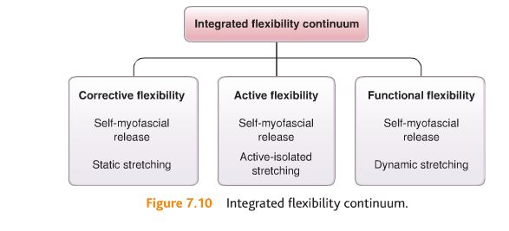

Stretching Techniques
Myofascial Release
- Self-myofascial release is stretching technique that focuses on the neural system and fascial system in the body. By applying gentle force to an adhesion or “knot,” the elastic muscle fibers are altered from a bundled position(which causes the adhesion) into a straighter alignment with the direction of the muscle or fascia. The gentle pressure will stimulate the Golgi tendon organ and create autogenic inhibition, decreasing muscle spindle excitation and releasing the hypertonicity(tension) of the underlying musculature. Gentle pressure(similar to massage) breaks up knots within muscle and helps to release unwanted muscular tension.
- When person finds tender spot(indicates presence of muscle hypertonicity) and sustain pressure on that spot for minimum of 30 seconds. This will cause Golgi tendon organ activity and decrease muscle spindle activity, thus triggering autogenic inhibitory response. It may take longer, depending on client’s ability to consciously relax. Process will help restore body back to its optimal level of function by resetting proprioceptive mechanisms of soft tissue. Self-myofascial release is suggested before stretching because breaking up fascial adhesions(knots) may potentially improve tissue’s ability to lengthen through stretching techniques.
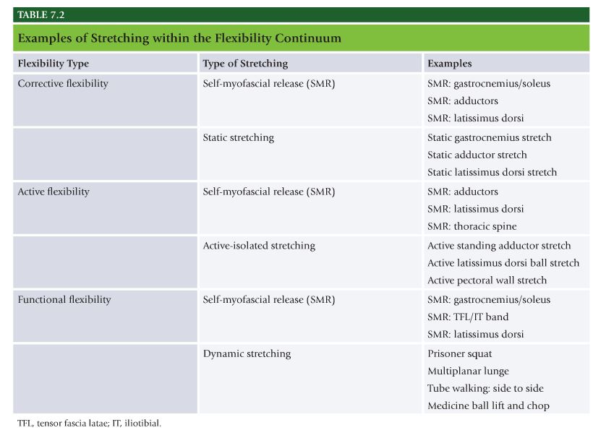
Static Stretching
- Static Stretching – Process of passively taking a muscle to the point of tension and holding the stretch for a minimum of 30 seconds.
- By holding muscle in stretched position for prolonged period, Golgi Tendon organ is stimulated and produces inhibitory effect on muscle spindle(autogenic inhibition). This allows muscle to relax and provides for better elongation of the muscle. In addition, contracting the antagonistic musculature while holding the stretch can reciprocally inhibit the muscle being stretched, allowing it to relax and enhancing the stretch.
- Static stretching should be used to decrease muscle spindle activity of a tight muscle before and after activity.
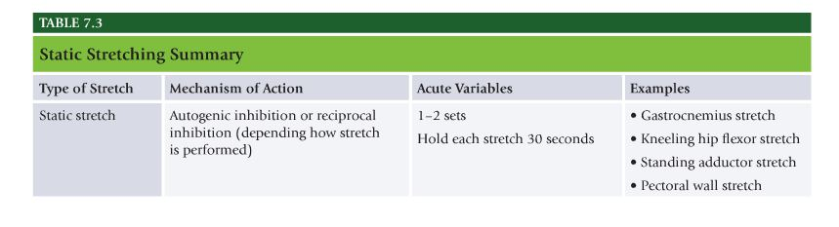
Active-Isolated Stretching
- Active-Isolated Stretch – Process of using agonists and synergists to dynamically move the joint into a range of motion.
- Increases motorneuron excitability, creating reciprocal inhibition of muscles being stretched. Active supine biceps femoris stretch is good example of active-isolated stretching. Quads extends the knee, this enhances the stretch in two ways. First, increases the length of biceps femoris, second contraction of the quadriceps causes reciprocal inhibition(decreased neural drive and muscle spindle excitation) of hamstring complex, which allows it to elongate.
- Active-isolated stretches are suggested for preactivity warm-up(before sports competition or high-intensity exercise), as long as no postural distortions are present. 5-10 reps of each stretch are performed and held for 1-2 seconds each.
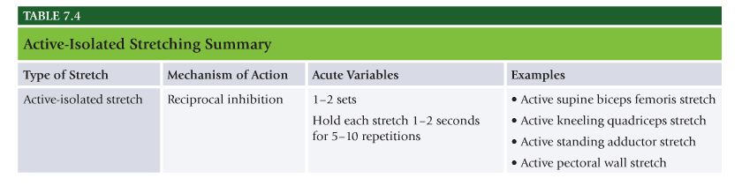
Dynamic Stretching
- Dynamic Stretching – Uses force production and momentum to move the joint through the full available range of motion.
- Uses the concept of reciprocal inhibition to improve soft tissue extensibility. One can perform one set of 10 reps using 3 of 10 dynamic stretches. Hip swings, medicine ball rotations, and walking lunges are good examples of dynamic stretching.
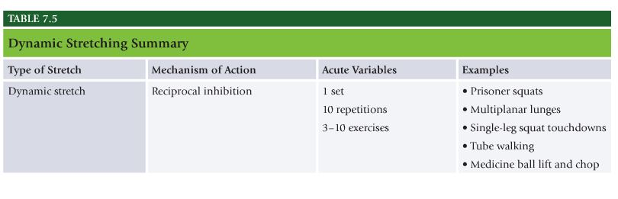

Chapter 8 – Cardiorespiratory Fitness Training

Chapter 8 Cardiorespiratory Fitness Training:
Know all definitions throughout the chapter:
- Overtraining page
- General vs. Specific Warm-up
- Cool down Phase
- Figure 8.1 FITTE factors
- Table 8.9 Training Zones
- Circuit Training

Cardiorespiratory Fitness Training
- Cardiorespiratory Fitness – Ability of the circulatory and respiratory systems to supply oxygen-rich blood to skeletal muscles during sustained physical activity. One of five components to health-related physical fitness; others are muscular strength, muscular endurance, flexibility, and body composition. Top priority from standpoint of preventing chronic disease and improving health and quality of life.
- Integrated Cardiorespiratory Training – Cardiorespiratory training programs that systematically progress clients through various stages to achieve optimal levels of physiological, physical, and performance adaptations by placing stress on the cardiorespiratory system. Personal trainers fail to take into effect the rate of progression, rate of progression critical to helping clients achieve personal health and fitness goals in most efficient and effective use of time and energy.
- Initial exercise prescription should reflect initial fitness level of client, fitness assessment results, and whether the client has any significant risk factors or health limitations to exercise. Warm-up, conditioning, cool-down.

Warm-up Phase
- General Warm-Up – Low intensity exercise consisting of movements that do not necessarily relate to the more intense exercise that is to follow.
- Specific Warm-Up – Low-intensity exercise consisting of movements that mimic those that will be included in the more intense exercise that is to follow.
- Suggested warmup activities – Self myofascial release, static stretching, cardio exercise. Sedentary clients or health limitations or previous injuries may have half or more dedicated workout time to warm-up activities.

Cooldown Phase
- At rest only 15-20% of circulating blood reaches skeletal muscle, but during intense vigorous exercise it increases up to as much as 80 to 85% of cardiac output. During exercise blood is shunted from major organs and redirected to skin to promote heat loss. Blood plasma volume also decreases, increased blood pressure forces water from vascular compartment to interstitial space. Plasma volume can decrease by as much as 10 to 20%. Cool-down period helps gradually restore physiological responses to exercise close to baseline levels.

General Guidelines for Cardiorespiratory Training
- FITTE – Frequency, intensity, time, type, enjoyment
- Frequency – number of training sessions in a given timeframe. Usually expressed as per week. Recommended frequency of activity is every day of week for small quantities of time for general health, for improved fitness levels frequency is 3 to 5 days per week at higher intensity.
- Intensity – Level of demand that a given activity places on the body. Established and monitored in numerous ways including calculating heart rate, power output(watts), or calculating VO2 max. Moderate exercise is 60% VO2 max or less. Talk comfortable during exercise for general health.
- VO2 max – Highest rate of oxygen transport and utilization achieved at maximal physical exertion.
- Oxygen Uptake Reserve – Difference between resting and maximal or peak oxygen consumption.

Methods for prescribing exercise intensity
- Peak VO2 Method. Traditional gold standard for measuring cardiorespiratory fitness. VO2 max. Maximal volume of oxygen per kilogram of body weight per minute. Maximal amount of oxygen that individual can use during intense exercise. Difficult to measure.
- Peak Metabolic Equivalent(MET) Method – One MET is 3.5 ML O2 per KG per Min, or equivalent of average resting metabolic rate for adults. Activity with 4 METS will require 4 times energy that person consumes at rest.
- Peak Maximal Heart Rate (MHR) Method – Most used formula is 220-Age. Never use 220-Age to calculate max heart rate as absolute.
- HR Reserve(HRR) Method – Karvonen method. Establishing training intensity based on difference between predicted maximal heart rate and resting heart rate. Most common and universally accepted method of establishing exercise training intensity. THR = [(HRmax – HRrest) x desired intensity] + HR rest
- Ratings of perceived exertion method – Used to express or validate how hard a client feels he or she is working during exercise. (RPE) method person is subjectively rating perceived difficulty of exercise. 6 is no exertion at all, 20 is maximal exertion.
- Talk test method – Informal method used to gauge exercise training intensity.
- Ventilatory threshold – Point during graded exercise in which ventilation increases disproportionately to oxygen uptake, signifying a switch from predominately aerobic energy production to anaerobic energy production.
- Time – Length of time an individual is engaged in a given activity. Adults should accumulate 2 hrs and 30 mins of moderate intensity aerobic activity or 1 hr 15 mins of intense aerobic activity.
- Type – Mode or type of activity selected. For exercise to be considered aerobic it must be rhythmic in nature, use large muscle groups, and be continuous in nature.
- Enjoyment – Amount of pleasure derived from performing a physical activity.

Cardiorespiratory Training Methods
Stage Training
- Purpose of stage training is to ensure that cardiorespiratory training programs progress in an organized fashion to ensure continual adaptation and to minimize risk of overtraining and injury.
- Overtraining – Excessive frequency, volume, or intensity of training, resulting in fatigue.

Stage 1
- Designed to help improve cardiorespiratory fitness levels in apparently healthy sedentary clients using target heart rate of 65 to 75% or max HR. 12 to 13 on rating of perceived exertion scale. Client should be able to hold a conversation during activity. Stage 1 clients start slowly and gradually work up to 30 to 60 minutes of continuous exercise in zone one. Clients who can maintain zone one HR for at least 30 minutes two to three times per week will be ready for stage II.

Stage 2
- Designed for clients with low to moderate cardiorespiratory fitness levels who are ready to begin training at higher intensity levels. Focus on increasing workload(speed, incline, level) Stage 2 helps increase cardiorespiratory capacity needed for workout styles in strength level of OPT model.
- Interval training, intensities varies throughout workout.
- Start by warming up in zone one for 5 to 10 minutes.
- Move into 1-minute interval in zone two. Gradually increase workload to raise heart rate up to zone two within that minute. Once heart rate reaches zone 2 of maximal heart rate, maintain it for rest of that minute. After 1 minute interval return to zone one for 3 mins.
- Repeat this, most important part of interval is to recover back to zone one between intervals.
- Stage 2 it is important to alternate days of the week with stage 1 training. Alternating sessions every workout.

Stage 3
- For advanced client who has moderately high cardiorespiratory fitness level base and will use heart rate zones one, two, and three. Stage III training increases capacity of energy systems needed at the power level of the OPT model.
- Warm up in zone one for up to 10 minutes.
- Increase workload every 60 seconds until reaching zone three. Require slow climb through zone two for at least two minutes.
- After pushing for another minute in zone three, decrease workload. One minute break is important to help gauge improvement.
- Drop client’s workload down to the level he or she was just working in, before starting zone 3 interval.
- As improvements are made during several weeks of training, heart rate will drop more quickly. Faster HR drops, stronger heart is getting.
- If client is not able to drop appropriate heart rate during 1-minute break, assume he or she is tired and about to overtrain. Solution is stay in zone one or two for rest of workout.
- If heart rate does drop to a normal rate, then overload the body again and go to next zone, zone three, for 1 minute.
- After this minute go back to zone one for 5-10 minutes and repeat if desired.
- Rotate all three stages, low stage(stage 1), medium(stage II), and high-intensity(stage III) to help minimize risk of overtraining.

Circuit Training
- Allows for comparable fitness results without spending extended periods of time to achieve them. Very time-efficient manner in which to train a client and will be thoroughly described as it pertains to cardiorespiratory training.
- Circuit-training consists of series of strength-training exercises that an individual performs, one after another, with minimal rest.
- Circuit training was just as beneficial as traditional forms of cardiorespiratory exercise for improving or contributing to improved fitness levels.
- Circuit training resulted in higher postexercise metabolic rates as well as strength levels.

NASM Chapter 9 – Core Training Concepts

Chapter 9 Core Training Concepts:
- Know all definitions throughout the chapter
- Local Stabilization System
- Global Stabilization System
- Table 9.1 Muscles of the Core
- It is your responsibility to learn how to categorize, progress, and regress body position while performing certain types of exercises.
- The OPT model is divided into three different blocks of training and each building block contains specific phases of training that systematically advances the student in a safe and progressive manner. Exercises can be categorized by adaptation and by type of exercise:
- OPT Level (adaptation): Stabilization, Strength, or Power (be familiar with all exercises listed, as well as how to regress and progress the exercises listed)
- Type of Exercise: Core
- Table 9.3 Core training program design

Core Musculature
- Core – Structures that make up lumbo-pelvic-hip complex(LPHC) including lumbar spine, pelvic girdle, abdomen, and hip joint.
- Core is where body’s center of gravity is located and where all movement originates. Strong and efficient core is necessary for maintaining proper muscle balance throughout the entire human movement system(kinetic chain).
- Optimal length-tension relationships, recruitment patterns, and joint motions in muscle of LPHC establish neuromuscular efficiency throughout entire human movement system. Allow for efficient acceleration, deceleration, and stabilization during dynamic movements, as well as prevention of possible injuries.

Local Stabilization System
- Local stabilizers are muscles that attach directly to vertebrae. Consist primarily of slow twitch type I fibers with high density of muscle spindles. Work to limit excessive compressive, shear, and rotational forces between spinal segments.
- Primary muscles that make up local stabilization system include transverse abdominis, internal obliques, multifidus, pelvic floor musculature, and diaphram. INcrease intra-abdominal pressure(pressure within abdominal cavity) and generating tension in thoracolumbar fascia(connective tissue of low back), increasing spinal stiffness for improved intersegmental neuromuscular control.

Global Stabilization System
- Muscles of global stabilization system attach from pelvis to the spine. These transfer loads between upper extremity and lower extremity, provide stability between pelvis and spine, and provide stabilization and eccentric control of the core during functional movements.
- Primary muscles that make up global stabilization system include quadratus lumborum, psoas major, external obliques, portions of the internal oblique, rectus abdominis, gluteus medius, and adductor complex.

Movement System
- Movement system includes muscles that attach the spine and/or pelvis to the extremities. These muscles are primarily responsible for concentric force production and eccentric deceleration during dynamic activities. Primary muscles that make up movement system include latissimus dorsi, hip flexors, hamstring complex, and quadriceps.
- Collectively all muscles within each system provide dynamic stabilization and neuromuscular control of entire core (LPHC). These produce force(concentric), reduce force(eccentric), and provide dynamic stabilization in all planes of movement during functional activities. In isolation, these muscles do not effectively achieve stabilization of LPHC; rather it is through their synergistic interdependent functioning that they enhance stability and neuromuscular control.
- Training movement system muscles before training muscles of global and local stabilization systems would not make sense from structural and biomechanical standpoint. Doing so would be analogous to building a house with no foundaiton.

Importance of Properly Training the Stabilization Systems
- Some active individuals have developed strength, power, and muscular endurance in the movement system, which enables them to perform functional activites. Few people have developed the local stabilization muscles required for intervertebral stabilization. The body’s core stabilization system has to be operating with maximal eficiency to effectively use the strength, power, and endurance that has been developed in prime movers. If movement system musculature of the core is strong and local stabilization system is weak, the kinetic chain senses imbalance and forces are not transferred or used properly. This leads to compensation, synergistic dominance, and inefficient movements.
- Weak core can lead to inefficient movement and predictable patterns of injury. Resulting in lower back pain and injury.

Scientific Rationale for Core Stabilization Training
- Individuals with chronic LBP have decreased activation of certain muscles or muscle groups, including transverse abdominis, internal obliques, pelvic floor muscles, multifius, diaphram, and deep erector spinae. Also weaker back extensor muscles and decreased muscular endurance.
- Studies support role of core training in prevention and rehabilitation of lower back pain. Core stabilization exercises restore size, activation, and endurance of multifidus(deep spine muscle) in individuals with lower back pain. Programs that include specific core stabilization training tend to be more effective than manual therapy alone.
- Drawing-in Maneuver – Used to recruit the local core stabilizers by drawing the navel in toward the spine.
- Bracing – Occurs when you have contracted both the abdominal, lower back, and buttock muscles at the same time.
- Traditional low-back hyperextension exercises without proper lumbo-pelvic-hip stabilization have been shown to increase pressure on discs to dangerous levels.

Drawing-in Maneuver
- Research has demonstrated electromyogram (EMG) activity is increased during pelvic stabilization and transverse abdominis activation when an abdominal drawing maneuver is initiated before activity.
- Transverse abdominis, when properly activated, creates tension in thoracolumbar fascia, contributing to spinal stiffness, and compresses sacroiliac joint, increasing stability.
- Pull region just below navel toward spine and maintain cervical spine in neutral position. Maintaining neutral spine during core training helps improve posture, muscle balance, and stabilization. If forward protruding head is noticed during drawing-in maneuver, sternocleidomastoid (large neck muscle) is preferentially recruited, which increases the compressive forces in the cervical spine and can lead to pelvic instability and muscle imbalances as a result of the pelvo-ocular reflex. Important to maintain the eyes level during movement.

Bracing
- Co-contraction of global muscles, such as rectus abdominis, external obliques, and quadratus lumborum. Muscular endurance of global and local musculature, when contracted together, create the most benefit for those with LBP compared with traditional LBP training methods.
- Bracing focuses on global trunk stability, not on segmental vertebral stability, meaning that the global muscles, given the proper endurance training, will work to stabilize the spine.

Guidelines for Core Training
- Core training should be systematic, progressive, functional, and emphasize the entire muscle action spectrum focusing on force production, force reduction, and dynamic stabilization. Core training program should regularly manipulate plane of motion, range of motion, modalities(tubing, stability ball, medicine ball, Bosu ball, Airex pad, etc.) body position, amount of control, speed of execution, amount of feedback, and specific acute training variables(sets, reps, intensity, tempo, and frequency).
- When designing core training program, personal trainer should initially create a proprioceptively enriched(controlled yet unstable) selecting appropriate exercises to elicit maximal training response.
- Core exercises performed in unstable environment(such as with stability ball) have been demonstrated to increase activation of local and global stabilization systems when compared to traditional trunk exercises.
- Safe and challenging, stress multiple planes in a multisensory environment derived from fundamental movement skills specific to activity.

Designing a Core Training Program
- Goal of core training is to develop optimal levels of neuromuscular efficiency, stability(intervertebral and lumbopelvic stability-local and global stabilization systems) and functional strength(movement system). Neural adaptations become focus of program instead of absolute strength gains.
- Increasing proprioceptive demand is more important than increasing external resistance.
- Quality of movement should be stressed over quantity.
- Client beings at highest level at which they are able to maintain stability and optimal neuromuscular control(coordinated movement). Progresses through program once mastery of exercise in previous level has been achieved while demonstrating intervertebral stability and lumbopelvic stability. Client has appropriate lumbopelvic stability when able to perform functional movement patterns(squats, lunges, step-ups, single-leg movements) without excessive spinal motion(flexion, extension, lateral flexion, rotation, singly or in combination). Critical that core training program is designed to achieve following functional outcomes:
- Intervertebral stability, lumbopelvic stability, movement efficiency

Levels of core training
- Three levels of training within OPT model, stabilization, strength, power, proper core training program follows same systematic progression.
- Core-Stabilization Training – Exercises involve little motion through the spine and pelvis. Designed to improve neuromuscular efficiency and intervertebral stability, focusing on drawing-in and then bracing during the exercises. Traditionally spend 4 weeks at this level of core training.
- Core Strength – Involve more dynamic eccentric and concentric movements of the spine throughout full range of motion while clients perform the activation techniques learned in core-stabilization training. Specificity, speed, and neural demands are progressed at this level. Traditionally spend 4 weeks at this level of core training.
- Core Power – Improve rate of force production of core musculature. Prepare an individual to dynamically stabilize and generate force at more functionally applicable speeds. Rotation chest pass, medicine ball pullover throw, front MB oblique throw, soccer throw.
- Core musculature helps protect spine from harmful forces that occur during functional activities. Core program designed to increase stabilization, strength, power, muscle endurance, and neuromuscular control in LPHC. Core training programs must be systematic, progressive, activity or goal-specific, integrated, and proprioceptively challenging. Proper core training follows same systematic approach as OPT model: stabilization, strength, and power.

Implementing a Core Training Program
- Requires that fitness professional follow progression of OPT model. Ex if client is in stabilization level(phase 1) select core stabilization exercises. For client in strength level, select core-strength exercises.
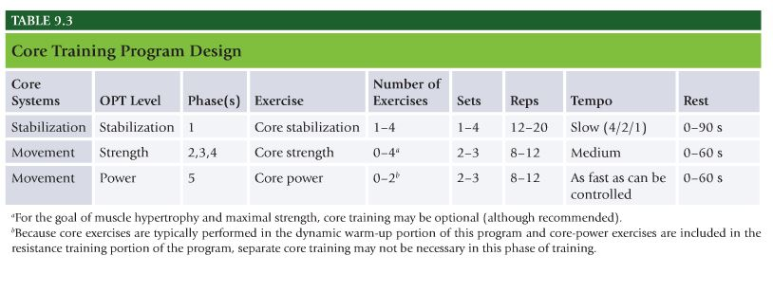

NASM Chapter 10 – Balance Training Concepts

Chapter 10 Balance Training Concepts:
- Figure 10.2 Effects of joint dysfunction
- Table 10.1 Balance training parameters
- OPT Level (adaptation): Stabilization, Strength, or Power
  - Be familiar with all exercises listed, as well as how to regress and progress the exercises listed
- Type of Exercise: Balance
- Table 10.2 Balance training program design

Core Concepts of Balance
- Key to all functional movements.
- Balance – When body is in equilibrium and stationary, meaning no linear or angular movement. Maintaining handstand without falling over.
- Dynamic Balance – ability to move and change directions under various conditions without falling. Running on uneven surfaces.
- Balance is dependent on internal and external factors to maintain body’s center of gravity over its base of support. Dynamic process involving multiple neurologic pathways.

Scientific Rationale for Balance Training
- Research shows that specific kinetic chain imbalances(such as altered length-tension relationships, force-couple relationships, and arthrokinematics) can lead to altered balance and neuromuscular inefficiency.
- Flawed movement patterns alter firing order of muscles activated.
- Joint dysfunction creates muscle inhibition. Leads to joint injury, swelling, interruption of sensory input from articular, ligamentous, and muscular mechanoreceptors to the central nervous system, results in clinically evident disturbance in proprioception.
- Sensory feedback to CNS is altered after ankle sprains, ligamentous injuries to the knee, and low-back pain.
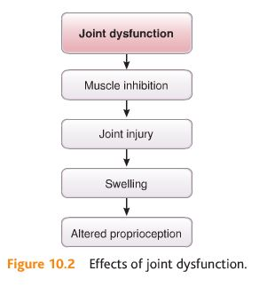

Importance of Properly Training the Balance Mechanism
- Balance training should stress individual’s limit of stability(or balance threshold). Limit of stability is distance outside of the base of support that he or she can move into without losing control of his or her center of gravity.
- Threshold must be stressed in multiplanar, proprioceptively enriched(unstable yet controlled) environment, using functional movement patterns to improve dynamic balance and neuromuscular efficiency.

Benefits of Balance Training
Balance training effects on injury
- Research shows performing exercises that demand balance can reduce rate of ankle sprains and other lower extremity injuries. Part of ACL injury prevention programs.
- Integrated injury prevention programs that include balance exercises in addition to plyometric or strength greatly influenced ability to improve lower extremity biomechanics.
- Should be performed at least 10 mins a day, 3 times a week, for 4 weeks.

Designing a Balance Training Program
- Must be systematic and progressive.
- Main goal of balance training is to continually increase client’s awareness of his or her limit of stability(or kinesthetic awareness) by creating controlled instability.
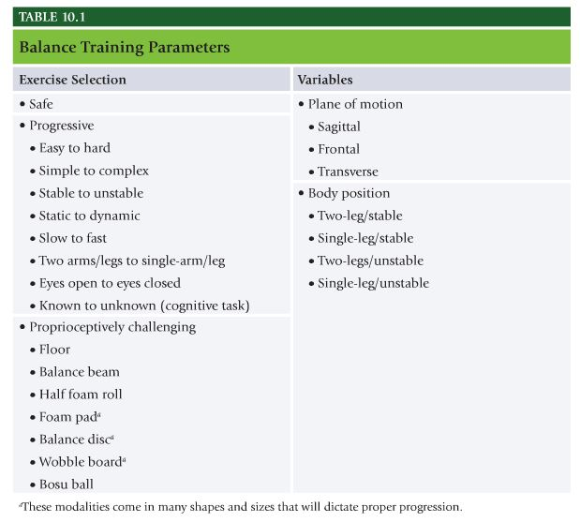
Levels of Training
- Three levels of training – stabilization, strength, and power. Proper balance training program follows same systematic progression.
- Surfaces change in difficulty as individual moves from stable surface(floor) to unstable surfaces(half foam roll, foam pad, balance disc). Eyes open is easier than eyes closed. Change one variable at a time.

Balance Stabilization Exercises
- Involve little joint motion; instead are designed to improve reflexive(automatic) joint stabilization contractions to increase joint stability.
- Sample exercises: single-leg balance, single-leg balance reach, single-leg hip internal and external rotation, single-leg lift and chop, single-leg throw and catch

Balance Strength Exercises
- Involve dynamic eccentric and concentric movement of balance leg, through full range of motion.
- Sample exercises: single-leg squat, single-leg squat touchdown, single-leg romanian deadlift, multiplanar step-up to balance, multiplanar lunge to balance

Balance Power Exercises
- Designed to develop proper deceleration ability to move body from dynamic state to a controlled stationary position, as well as high levels of eccentric strength, dynamic neuromuscular efficiency, and reactive joint stabilization.
- Exercises include: multiplanar hop with stabilization, multiplanar sing-leg box hop-up with stabilization, multiplanar single-leg box hop-down with stabilization.

Implementing a Balance Training Program
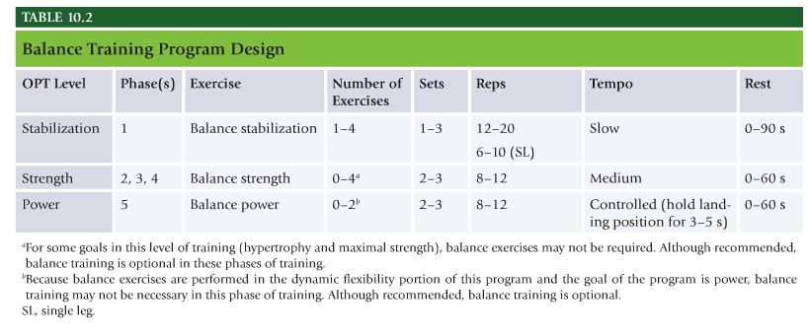

NASM Chapter 11 – Plyometric (Reactive) Training Concepts

Chapter 11 Plyometric Training Concepts:
- Know all definitions throughout the chapter
- Integrated performance paradigm
- The phases of Plyometric Exercise
- Figure 11.2 Program design parameters for reactive training
- OPT™ Level (adaptation): Stabilization, Strength, or Power (be familiar with all exercises listed, as well as how to regress and progress the exercises listed)
- Type of Exercise: Balance
- Table 11.1 Plyometric training program design

Principles of Plyometric Training
- Also known as jump or reactive training, form of exercise that uses explosive movements such as bounding, hopping, and jumping to develop muscular power.
- Plyometric training is type of training where individual reacts to the ground surface in such a way that they develop larger than normal ground forces that can then be used to project body with greater velocity or speed of movement.
- Reactive training refers to reaction stimulus clients encounter during plyometric training, which is ground surface in this case, therefore reactive and plyometric are used interchangeably.
- Individuals must possess adequate core strength, joint stability, and range of motion and have ability to balance efficiently before performing any plyometric exercises.

What is Plyometric Training?
- Enhanced performance during functional activities emphasizes the ability of muscles to exert maximal force output in a minimal amount of time(also known as rate of force production).
- Rate of Force Production – Ability of muscles to exert maximal force output in minimal amount of time.
- Success in everyday activities and sport depends on speed at which muscular force is generated. Speed of movement is function of training, reactive neuromuscular control is function of learning. Key then is muscular overload and rapid movements during execution of training exercises.
- Plyometric (reactive) training – Exercises that generate quick, powerful movements involving an explosive concentric muscle contraction preceded by an eccentric muscle action.
- Explosive muscular contractions can be seen in practical instances such as rebounding in basketball.
- Integrated Performance Paradigm – Move with efficiency, forces must be dampened(eccentrically), stabilized(isometrically), and then accelerated(concentrically). So muscles must slow down in eccentric phase, pause isometrically, then explosively accelerate in concentric phase.

Three phrases of Plyometric Exercise
- Eccentric Phase – First stage of plyometric movement, classified as eccentric phase, but also called deceleration, loading, yielding, counter movement, or cocking phase. Phase increases muscle spindle activity by prestretching the muscle before activation. Potential energy stored in the elastic components of the muscle during this loading phase much like stretching a rubber band.
- Amortization Phase – Dynamic stabilization and is time between end of eccentric muscle action and initiation of concentric contraction. Prolonged amortization phase results in less than optimal neuromuscular efficiency from a loss of elastic potential energy. Rapid switch from eccentric loading to concentric contraction leads to a more powerful response.
- Concentric phase – occurs immediately after amortization phase, involves concentric contraction.

Importance of Plyometric Training
- Plyo exercises enhance excitability, sensitivity, and reactivity of neuromuscular system and increase the rate of force production(power), motor unit recruitment, firing frequency(rate coding) and motor unit synchronization.
- These exercises can be incorporated once client has achieved an overall strength base, proper core strength, and balance stabilization capabilities.
- All movement patterns that occur during functional activities involve a series of repetitive stretch-shortening cycles(eccentric and concentric contractions). Stretch-shortening cycles require neuromuscular system to react quickly and efficiently after an eccentric muscle action to produce a concentric contraction and impart necessary force(or acceleration) in the appropriate direction. Plyometric training prepares client for functional demands of specific activity.
- Plyometric training provides ability to train specific movement patterns in a biomechnically correct manner at more functionally appropriate speed. Ultimate goal of plyometric training is to decrease the reaction time of muscle action spectrum, this is what results in increased speed of movement in the individual.
- Speed of muscular exertion is limited by neuromuscular coordination. Means that the body will only move within a range of speed that the nervous system has been programmed to allow. Plyo training improves neuromuscular efficiency and improves range of speed set by CNS.
- Often overlooked in traditional training programs.

Designing a Plyometric Training Program
Stabilization Exercises
- Involve little joint motion. Designed to establish optimal landing mechanics, postural alignment, and reactive neuromuscular efficiency(coordination during dynamic movement). When individual lands they should hold the landing position for 3 to 5 seconds.
- Exercises: Squat jump with stabilization, box jump-up with stabilization, box jump-down with stabilization, multiplanar jump with stabilization
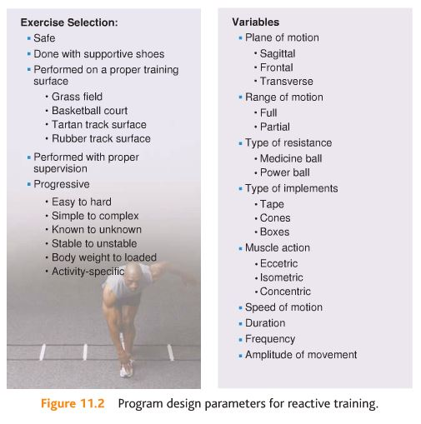
Plyometric Strength Exercises
- Exercises involve more dynamic eccentric and concentric movement through a full range of motion. Specificity, speed, and neural demand may also be progressed at this level. Exercises are intended to improve dynamic joint stabilization, eccentric strength, rate of force production, and neuromuscular efficiency of the entire human movement system. Performed in repetitive fashion(spending relatively short time on the ground before repeating the drill).
- Exercises: Squat jump, tuck jump, butt kick, power step-up

Plyometric Power Exercises
- Exercises involve entire muscle action spectrum and contraction-velocity spectrum used during integrated, functional movements. Designed to further improve the rate of force production, eccentric strength, reactive strength, reactive joint stabilization, dynamic neuromuscular efficiency, and optimal force production. Performed as fast and explosively as possible.
- Exercises: Ice-skaters, single-leg power step-up, proprioceptive plyometrics.

Designing a Plyometric Training Program
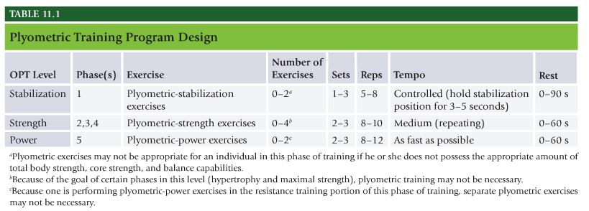

NASM Chapter 12 – Speed, Agility, and Quickness Training

Chapter 12 Speed, Agility, and Quickness Training:
- Know all definitions throughout the chapter
- Table 12.1 Kinetic Chain checkpoints during running movements- pay attention to the foot/ankle complex
- Table 12.2 SAQ Program Design

Concepts in Speed, Agility, and Quickness Training
- Similar to plyometric training. Speed is referred to distance covered divided by time. Agility refers to short bursts of movement that involve a change in direction, cadence, or speed. Quickness refers to the ability to react to stimulus and appropriately change the motion of the body.
- Enhances client’s ability to accelerate, decelerate, and dynamically stabilize their entire body during higher-velocity acceleration and deceleration movements.

Speed
- Speed – The ability to move the body in one intended direction as fast as possible.
- Stride Rate – The number of strides taken in a given amount of time(or distance).
- Stride Length – Distance covered in one stride, during running.
- Speed is a skill that can be learned through an integrated training program.
- Proper running mechanics allows client to maximize force generation through bio mechanical efficiency.
- Frontside mechanics – Proper alignment of lead leg and pelvis during sprinting, which includes ankle dorsiflexion, knee flexion, hip flexion, and neutral pelvis. Involves triple flexion of the ankle, knee, and hip in appropriate synchrony. Improved frontside mechanics is associated with better stability, less braking forces, and increased forward driving forces.
- Backside mechanics – Proper alignment of rear leg and pelvis during sprinting, which includes ankle plantarflexion, knee extension, hip extension, and neutral pelvis. Associated with stronger push phase, including hip-knee extension, gluteal contraction, and backside arm drive.

Agility
- Agility – Ability to accelerate, decelerate, stabilize, and change direction quickly while maintaining proper posture. Requires high levels of neuromuscular efficiency to be able to maintain one’s center of gravity over base of support while changing directions at various speeds.
- Proper agility training can help prevent injury by enhancing body’s ability to effectively control eccentric forces in all planes of motion as well as by improving structural integrity of connective tissue.
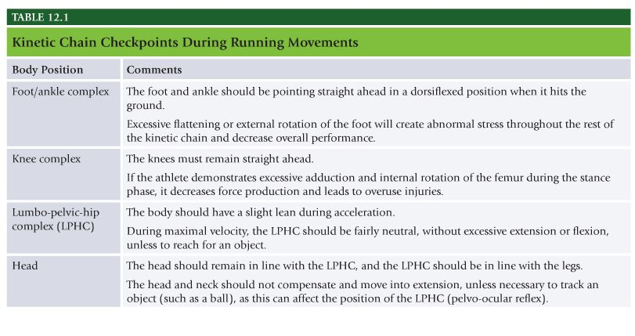

Quickness
- Quickness – The ability to react and change body composition with maximal rate of force production, in all planes of motion and from all body positions, during functional activities. Involves ability to assess visual, auditory, or kinesthetic stimuli and to provide the appropriate physical response as fast as possible(such as hitting a baseball or swerving to avoid car accident).

Speed, Agility, and Quickness for Nonathletic Populations
- Widely used and accepted way to improve sports performance in athletes, components of SAQ program also significantly improve physical health profile of apparently healthy sedentary adults and those with medical or health limitations. Increased neuromuscular, biomechanical, and physiological demand for such training can aid in weight loss, coordination, movement proficiency, and injury prevention when applied safely and effectively as seen in OPT model.

SAQ Training Programs for Youth
- Children are constantly growing, developing, and maturing until early adulthood. Children are programmed to develop progressively higher neuromuscular capabilities in line with their physical and mental maturation. Environment must challenge children’s biologic systems; must learn through external measures how to adapt and apply appropriate movement patterns.
- SAQ programs decrease likelihood of athletic injury, increase likelihood of exercise participation later in life, and improve physical fitness.
- Red light green light drills, follow the snake.

SAQ Training for Weight Loss
- Interval training is highly effective in improving variety of health-related factors. High intensity, short bouts of SAQ drills make them valid choice for interval training modalities with appropriate nonathletic populations.
- When designing SAQ programs for weight loss, primary focus is to keep heart rate appropriately elevated to increase fat oxidation and caloric expenditure.
- Jump rope/cone shuffle circuit.

SAQ Training for Seniors
- Primary function of SAQ for seniors is to prevent age-related decreases in bone density, coordinative ability, and muscular power. Aids in prevention of injury and increase in quality of life.
- Movement confidence and proficiency are essential in senior populations to aid in prevention of falls and maintain activities of daily life.
- Sarcopenia, age-related loss of skeletal muscle mass, slowing sarcopenia are interventions requiring speed of movement and rate of force production.

SAQ Drills and Programming Strategies
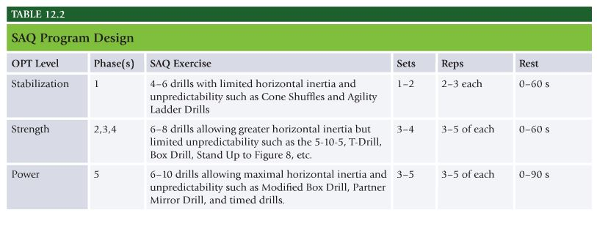

NASM Chapter 13 – Resistance Training Concepts

Chapter 13 Resistance Training Concepts:
- General Adaptation Syndrome
- Table 13.1 Adaptive benefits of resistance training
- Table 13.2 The general adaptation syndrome
- SAID Principle
- Adaptations for resistance training
- Table 13.3 Resistance training systems
- Table 13.4 Peripheral heart action system

On the exam, some questions may ask about how to properly progress body position during an exercise. You need to be able to progress (make more difficult), or regress (make easier) a client’s body position. Below, progressions are listed from easy to difficult and you can see that two-legs on a stable surface (the floor) is easier than standing on one leg (single-leg), on the floor. With the arms, start a client with two arms, before progressing on to an alternating arm, and then to a single arm exercise. For example:
What would be the immediate progression of a “Single-Leg Dumbbell Curl”?
a. single-leg, alternating arm, stable
b. single-leg, single-arm, stable
c. two-leg, alternating arm, unstable
d. two-leg, single-arm, unstable

General Adaptation Syndrome
- Optimal state of human movement system is one of physiologic balance or homeostasis.
- General Adaptation Syndrome – Used to describe how the body responds and adapts to stress. For adaptations to occur, the body must be confronted with a stressor of some form that creates the need for a response.
- Three stages of response to stress: alarm reaction, resistance development, exhaustion
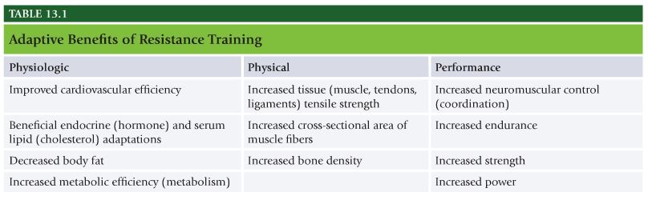
Alarm Reaction Stage
- Alarm Reaction – The initial reaction to a stressor. Activates a number of physiological and psychological protective processes within the body. During initial sessions of resistance training programs, body is forced to try and adapt to increased amounts of force on bones, joints, muscles, connective tissues, and nervous system.
- During alarm stage numerous physiologic responses occur, including increase in oxygen and blood supply as well as neural recruitment to the working muscles.
- Over time applying principle of progressive overload, body increases its ability to meet demands being placed on it.
- Delayed onset muscle soreness – Pain or discomfort often felt 24 to 72 hours after intense exercise or unaccustomed physical activity.
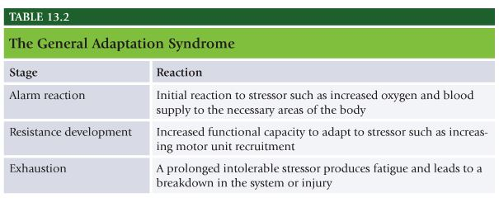
Resistance Development Stage
- Resistance Development – Body increases its functional capacity to adapt to the stressor. Human movement system will increase its capabilities to efficiently recruit muscle fibers and distribute oxygen and blood to proper areas of the body. Once adaptation has occurred, body will require increased stress or overload to produce a new response and a higher level of fitness.
- Personal trainers understand this adaptation response but use it improperly by only manipulating the amount of weight the client uses when this is one of many ways to increase stress on the body.

Exhaustion Stage
- Prolonged stress or intolerable amounts of stress can lead to exhaustion or distress.
- Exhaustion – prolonged stress or stress that is intolerable and will produce exhaustion or distress to the system.
- When stressor is too much for any one of the physiologic systems to handle, it causes a breakdown or injury such as: Stress fractures, muscle strains, joint pain, emotional fatigue.
- Avoiding pitfalls of exhaustion stage is one of main reasons for using OPT model.
- Periodization – Division of a training program into smaller, progressive stages.
- If resistance is continually increased with intention of stressing specific muscles or muscle groups to produce increase in size and strength, it can lead to injury of the muscle, joint, or connective tissue, especially if resistance is added too quickly or inadequate rest and recovery periods are not planned for.

Principle of Specificity: The SAID Principle
- Principle of Specificity or Specific Adaptation to Imposed Demands(SAID principle) – Principle that states the body will adapt to the specific demands that are placed on it. If someone repeatedly lifts heavy weights, that person will produce higher levels of maximal strength. Conversely if a person repeatedly lifts lighter weights for many reps, that person will develop higher levels of muscular endurance.
- Training programs should reflect desired outcomes.
- Type I slow twitch fibers are smaller in diameter, slower to produce maximal tension, and more resistant to fatigue.
- Type II are larger, fast twitch, quick to produce maximal tension, fatigue more quickly than type I.
- Degree of adaptation that occurs during training is directly related to the mechanical, neuromuscular, and metabolic specificity of the training program. To effectively achieve program goals for clients, trainers need to consistently evaluate the need to manipulate the exercise routine to meet actual training goals. The body can only adapt if it has a reason to adapt.
- Mechanical Specificity – The weight and movements placed on the body. To develop muscular endurance of legs requires light weights and high repetitions when performing leg-related exercises. To develop maximal strength in the chest, heavy weights must e used during chest-related exercises.
- Neuromuscular Specificity – Refers to the speed of contraction and exercise selection. To develop higher levels of stability while pushing, chest exercises will need to be performed with controlled, unstable exercises, at slower speeds. To develop strength, exercises should be performed in more stable environments with heavier loads to place more of an emphasis on the prime movers. To develop higher levels of power, low-weight high-velocity contractions must be performed in a plyometric manner.
- Metabolic Specificity – Refers to the energy demand placed on the body. To develop endurance, training will require prolonged bouts of exercise, with minimal rest between sets. Endurance training primarily uses aerobic pathways to supply energy to the body. To develop maximal strength or power, training will require longer rest periods, so the intensity of each bout of exercise remains high. Energy will be supplied primarily via anaerobic pathways.
- Trainers should remember that a client’s training program should be designed to meet the specific demands of their daily life and health and wellness goals.
- Mechanically body burns more calories when movements are performed while standing versus seated or lying position.
- From neuromuscular standpoint, body burns more calories when more muscles are being used for longer periods in controlled, unstable environments.
- Metabolically, body burns more calories when rest periods are short to minimize full recuperation.

Progressive Adaptations from Resistance Training
Stabilization
- Stabilization is the human movement system’s ability to provide optimal dynamic joint support to maintain correct posture during all movements. Getting right muscles to fire, with right amount of force, in the proper plane of motion, at the right time.
- If training is not performed with controlled unstable exercises, clients will not gain the same level of stability and may even worsen.

Muscular Endurance
- Muscular Endurance – The ability to produce and maintain force production for prolonged periods of time. Improving muscular endurance is integral component of all fitness programs.
- Research has shown that resistance training protocols using high reps are the most effective way to improve muscular endurance as well and after an initial training effect in previously untrained individuals, multiple sets of periodized training may prove superior to single-set training for improving muscular endurance.

Muscular Hypertrophy
- Muscular Hypertrophy – Enlargement of skeletal muscle fibers in response to overcoming force from high volumes of tension. Seen in resistance training. Visible signs of hypertrophy may not be apparent for many weeks(4-8 weeks), in an untrained client, process begins in the early stages of training, regardless of the intensity of training used.
- Resistance training protocols that use low to intermediate rep ranges with progressive overload lead to muscular hypertrophy. Structured progressive training programs use multiple sets to help increase musculoskeletal hypertrophy in both younger and older men and women alike. Progressive resistance training programs using moderate to low rep protocols with progressively higher loads will result in increased hypertrophy in older adults and men and women.

Strength
- Strength – ability of neuromuscular system to produce internal tension to overcome an external load. Degree of internal tension produced is the result of strength adaptations.
- Resistance training programs have traditionally focused on developing maximal strength in individual muscles, emphasizing one plane of motion, mainly sagittal. Because all muscles function eccentrically, isometrically, and concentrically on all three planes of motion at different speeds, training programs should be designed using a progressive approach that emphasizes the appropriate exercise selection, all muscle actions, and repetition tempos.
- Because muscle operates under the control of the CNS, strength needs to be thought of not as a function of muscle, but as a result of activating the neuromuscular system. Strength gains can occur rapidly in beginning clients and can increase with structured, progressive resistance training program.
- One factor in increased strength is an increase in number of motor units recruited, especially early in the training program.
- Strength is built on foundation of stabilization requiring muscles, tendons, and ligaments to be prepared for the load that will be required to increase strength beyond initial stages of training.

Power
- Power – Ability of neuromuscular system to produce the greatest force in the shortest time. Force multiplied by velocity. Power adaptations build on stabilization and strength adaptations and then apply them at more realistic speeds and forces seen in everyday life and sporting activities.
- Increase in either force or velocity will produce increase in power. Training for power can be achieved by increasing weight(force) or increasing the speed at which weight is moved(velocity).

Resistance Training Systems
- Originally power lifters, olympic lifters, and bodybuilders designed most resistance training programs. Research shows following systematic, integrated training program and manipulating key training variables achieve optimal gains in strength, neuromuscular efficiency, hypertrophy, and performance.
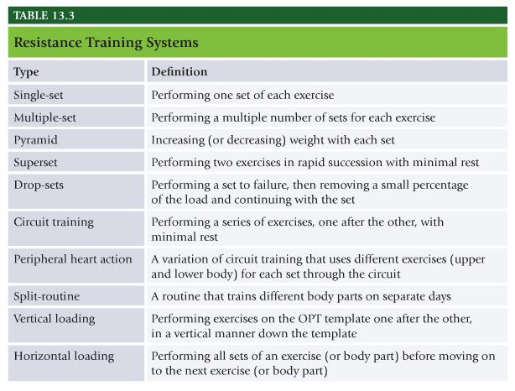
Single-Set System
- Uses 1 set per exercise. Usually recommended that single-set workouts be performed two times a week to promote sufficient development and maintenance of muscle mass.
- When reviewing physiology of how human movement system operates, notion that single set is not enough may not be true.
- Helps avoid synergistic dominance

Multiple-Set System
- Consists of performing multiple numbers of sets of exercise. Appropriate for both novice and advanced clients. Superior to single set training for advanced clients.

Pyramid System
- Progressive or regressive step approach that either increases weight with each set or decreases weight with each set. In light-to-heavy system, individual typically performs 10 to 12 reps with light load and increases resistance for each following set, until individual can perform 1 to 2 reps, usually in 4 to 6 sets. Easily be used for workouts that involve only 2 to 4 sets or higher rep schemes(12 to 20 reps). Heavy to light system works in opposite direction.

Superset System
- Two exercises, performed in rapid succession. Multiple variations of superset systems.
- First variation includes performing two exercises for same muscle group back to back. Example bench press immediately followed by push-ups.
- Other variation involves two exercises back to back that involve antagonist muscle groups.
- Involves 8-12 reps with no rest between sets or exercises.

Drop-Sets
- Allows client to continue a set past point at which it usually terminates. Performing set to failure, removing small percentage of load(5-20%), continuing with the set, completing a small number of reps(2-4), repeated several times(2-3 drops per set).

Circuit Training
- Series of exercises that an individual performs one after the other, minimal rest between each exercise. Low to moderate number of sets, moderate to high reps(8-20), short rest periods(15-60 secs).

Peripheral Heart Action System
- Another variation of circuit training that alternates upper body and lower body exercises throughout the circuit. Distributes blood flow between upper and lower extremities potentially improving circulation. Number of exercises per sequence varies with program’s goal. This system is very beneficial for incorporating an integrated, multidimensional program and for altering body composition.
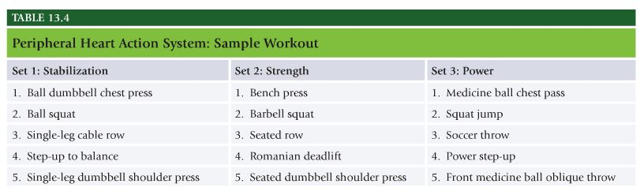

Split-Routine System
- Breaking body up into parts to be trained on separate days. Bodybuilders use mass dominant and strength athletes use split routine system. Numerous exercises on same day for same body part to bring optimal muscular hypertrophy.
Vertical Loading and Horizontal Loading
- Vertical Loading – Alternating body parts trained from set to set, starting from upper extremity and moving to the lower extremity.
- Goes from total body exercise, chest, back, shoulders, biceps, triceps, legs
- In vertically loaded workout client performs total body workout, then to chest, then to back, and so forth until all exercises have been completed. Client then start back at full body.
- Can be very beneficial in allowing for maximal recovery of each body part while minimizing amount of time wasted on rest.
- Horizontal loading – Performing all sets of exercise or body part before moving on to next exercise or body part. Appropriate for maximal strength and power training. Drawback is the amount of time typically spent resting.

NASM Study Guide Chapter 14 – Integrated Program Design and the Optimum Performance Training (OPT) Model

Chapter 14 Integrated Program Design and the Optimum Performance Training (OPT) Model:
Know all definitions throughout the chapter.
Tempo controls the amount of time that the muscle is active or producing tension – concentrically, isometrically, and/or eccentrically.
NASM writes tempos this way: “a/b/c”And tempo is always written in this way:
a = eccentric
b = isometric
c = concentric
Therefore, assuming the above, a 4/2/1 tempo on a one repetition of a bench press would be:
- 4 counts, controlled, eccentric deceleration, bringing the weight back down (before the push)
- 2 counts on the isometric stabilization at the bottom of the exercise
- 1 count on the push (upward)

Another example: a 2/0/2 tempo on one repetition of a bench press would be:
- 2 counts, controlled, eccentric deceleration, bring the weight down (into position, before the push upward)
- 0 no counts of isometric stabilization at the bottom
- 2 counts of concentric pushing (upward)

Focus on the following tables from Chapter 14:
- Table 14.2 Training volume adaptations
- Table 14.7 Phase 1: Stabilization Endurance Training
  - (all of the resistance training acute variable and tempo for core)
- Table 14.8 Phase 2: Strength Endurance Training
  - (all of the resistance training acute variable and tempo for core)
- Table 14.9 Phase 3: Hypertrophy Training
  - (all of the resistance training acute variable and tempo for core)
- Table 14.10 Phase 4: Maximal Strength Training
  - (all of the resistance training acute variable and tempo for core)
- Table 14.11 Phase 5: Power
  - (all of the resistance training acute variable and tempo for core)

Program Design
- Program Design – Purposeful system or plan put together to help an individual achieve a specific goal. Provide a pathway to help clients achieve their health and fitness goals.

Program Design using the OPT Model
- Planned, systematic, periodized training program. Designed to concurrently improve all functional abilities, such as flexibility, core stabilization, balance, strength, power, and cardiorespiratory endurance.

Acute Variables of Training
- Acute Variables – Important components that specify how each exercise is to be performed. The most fundamental component of designing a training program. They determine the amount of stress placed on the body and ultimately what adaptations the body will incur.
- Body will specifically adapt to demands placed upon it(known as principle of specificity). Acute variables applied during exercise program will dictate these demands and adaptations achieved. Collectively, acute variables are the foundation of program design.

Repetitions
- Repetition (or “Rep”) – One complete movement of a single exercise. Most reps will involve three muscle actions: concentric, isometric, and eccentric.
- Simply means to count the number of movements performed in a given amount of time. They can be a means to count time under tension.
- Each phase of OPT model has specific goals and therefore requires specific number of reps to achieve these goals. Number of reps performed in a given set is dependent on client’s work capacity, intensity of exercise, and specific phase of training.
- All acute variables are interdependent. Ex increasing load, fewer number of reps can be performed.
- Research shows training in a specific rep range yields specific adaptations.
- Muscular endurance and stabilization is best achieved by performing 12 to 20 reps at 50 to 70% 1RM
- Hypertrophy best achieved using 6 to 12 reps at 75 to 85% 1RM
- Maximal strength is achieved from 1 to 5 at 85 to 100% 1RM
- Power adaptations require 1 to 10 reps at 30-45% 1RM
- Beginning phases of OPT consists of high rep schemes necessary to build proper connective tissue(tendons, ligaments) strength, stability, and muscular endurance.
- Common mistake of advanced clients is to not use a planned training program that provides periods of low-rep training alternated with periods of high-rep training.
- Higher intensities of training can only be sustained for a short period without running the risk of overtraining.

Sets
- Set – Group of consecutive repetitions. Inverse relationship between sets, reps, and intensity. Individual usually performs fewer sets when performing higher reps at a lower intensity(endurance adaptations) and more sets when performing lower reps at a higher intensity(strength and power adaptations).
- Muscular endurance and stabilization, 1 to 3 sets, 12 to 20 reps 50 to 70% 1RM
- Hypertrophy 3 to 5 sets, 6 to 12 reps, 75 to 85% 1RM
- Maximal strength 4 to 6 sets, 1 to 5 reps, intensity of 85 to 100% 1RM
- Power adaptations 3 to 6 sets, 1 to 10 reps, 30 to 45% 1RM

Training Intensity
- Training Intensity – An individual’s level of effort, compared with their maximal effort, which is usually expressed as a percentage. One of the most important acute variables to consider when designing an integrated training program.
- Muscular endurance and stabilization is best developed with intensity of 50 to 70% 1RM
- Hypertrophy achieved with 75 to 85% 1RM
- Maximal strength with 85 to 100% 1RM
- Power with 30 to 45% 1RM
- Training in an unstable environment also increases the training intensity because it requires greater motor unit recruitment, leads to greater energy expenditure per exercise.

Repetition Tempo
- Repetition Tempo – The speed with which each rep is performed. Important variable that can be manipulated to achieve specific training objectives such as endurance, hypertrophy, strength, and power.
- Because movement occurs at different velocities, to get most appropriate results from training, personal trainers must select appropriate speed of movement(slower tempo for endurance and faster tempo for power).
- Muscular endurance and stabilization is best developed with slow rep tempo. One example would be 4 sec eccentric, 2 sec isometric, 1 sec concentric(4/2/1).
- Hypertrophy is achieved at moderate tempo, one example would be 2 second eccentric, 0 isometric, and 2 second concentric.(2/0/2)
- Maximal strength are best achieved with fast or explosive tempo.
- Power adaptations best achieved with fast or explosive tempo that can be safely controlled.
- OPT model places major emphasis on rep tempo because it has significant impact on functional outcome of the stressed tissues. By emphasizing eccentric and isometric muscle actions at slower velocities during stabilization phases of training, more demand is placed on connective tissue(as well as stabilizing muscles) and better prepares nervous system for functional movements.

Rest Interval
- Rest Interval – The time taken to recuperate between sets. Has a dramatic effect on the outcome of the training program.
- Muscular endurance and stabilization 0 to 90 seconds rest.
- Hypertrophy short rest periods between 0 and 60 secs.
- Maximal strength 3 to 5 min rest.
- Power 3 to 5 min rest.
- Dynamic resistance training and isometric training significantly reduce ATP and PC supplies.
- 20 to 30 seconds allows approx 50% recovery of ATP and PC
- 40 secs 75% of ATP and PC
- 60 secs 85 to 90% of ATP and PC
- 3 mins approx 100% of ATP and PC
- Rest interval between sets determines to what extent energy resources are replinished before next set. Shorter rest interval, less ATP and PC will be replenished, and less energy will be available.
- For new clients this fatigue can lead to decreased neuromuscular control, force production, and stabilization by decreasing motor unit recruitment. Therefore inadequate rest intervals can decrease performance and could lead to altered movement patterns and even injury.
- If rest periods are too long, potential effects include decreased neuromuscular activity and decreased body temp. If beginner client is then asked to perform intense bout of exercise, this could entail a potential increased risk of injury.
- Individuals who are starting an exercise routine may respond better to longer rest periods until they adjust to demands of their program. Longer rest periods also help to ensure proper exercise technique. By reducing fatigue, client may be able to perform exercise with greater precision.

Training Volume
- Training Volume – Amount of physical training performed within a specified period. Extremely important to plan and control training volume to prevent overtraining. All training is cumulative, training volume varies among individuals and is based on: training phase, goals, age, work capacity or training status, recoverability, nutritional status, injury history, life stress.
- For an individual to achieve optimal results from integrated training program, the program must provide them with appropriate planned training volume for extended periods. Volume is always inversely related to intensity. Individual cannot safely perform high volumes of high intensity exercises for an extneded period of time.
- Example when working with loads exceeding 90% of 1RM, one rarely exceeds a workout volume of 30 reps per exercise. However when working with loads of 60% maximum, client can easily perform workout volume of 36 to 60 reps.
- Training phase and training goal dictate the reps, sets, intensity, rest, and tempo, and these combine to dictate the volume.

Training Frequency
- Training Frequency – Number of training sessions performed during a specified period(usually 1 week). Considerable debate concerning adequate number of training sessions per body part per week necessary for optimal results.
- New clients may begin training their entire body two times a week. Experienced bodybuilders with specific goal of hypertrophy may have training cycle in which theyt rain with a split routine of six sessions per week, training each bodypart two times per week with larger volume per session.
- Optimal frequency for strength improvements is three to five times per week.
- One to two times per week is sufficient to maintain physical, physiologic, and performance improvements that were achieved during other phases of training.
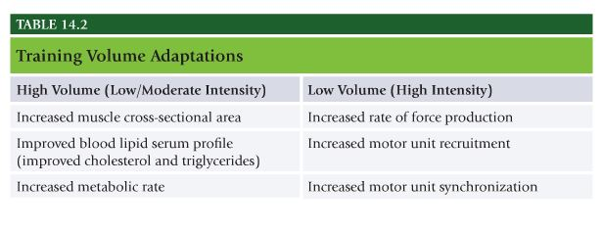
Training Duration
- Training Duration – Timeframe of a workout or the length of time spent in one phase of training. Training duration of a workout is a function of the number of reps, number of sets, number of exercises, and length of the rest intervals. Training programs that exceed 60 to 90 mins are associated with rapidly declining energy levels. Causes alterations in hormonal and immune system responses that can have negative impact on training program and raise risk of minor infections, especially upper respiratory system.
- Training duration for a phase of training is dictated by the client’s level of physical ability, goal, and compliance to the program. Typically, a phase of training will last 4 weeks, as this is amount of time it generally takes for body to adapt to a given stimulus.

Exercise Selection
- Exercise Selection – The process of choosing appropriate exercises for a client’s program. Has tremendous impact on the outcome of training program. Human movement system is highly adaptable system that readily adjusts to imposed demands of training. Therefore, exercises should be specific to the training goals.
- Exercises can be broken down into three different types based on the number of joints used, movements performed, and adaptation desired.
- Single joint – focus on isolating one major muscle group or joint(bicep curls, triceps pushdowns, calf raises).
- Multijoint – Use involvement of two or three joints(squats, lunges, step-ups, chest presses).
- Total body – Include multiple joint movements(step-up balance to overhead press, squat to two arm press, barbell clean).
- For example to develop optimal stability, traditional exercises can be progressed to a more unstable environment, such as standing up(two-leg, staggered-stance, and single-leg) or from a stable environment to an unstable environment(foam pad, stability ball, bosu ball).
- Exercises performed in unstable environments produce superior results for goal of stabilization and training the core stabilization muscles.

Periodization and the OPT Model (Planned Fitness Training)
- Understanding the importance of designing safe and effective programs using acute variable manipulation is important fundamental information for all personal trainers and ultimately their success in the profession.
- Periodization involves two primary objectives – divide training into distinct periods(or phases), train different forms of strength in each period(or phase) to control volume of training and prevent injury.

Training Plans
- Training Plan – Specific outline, created by fitness professional to meet a client’s goals, that details the form of training, length of time, future changes, and specific exercises to be performed. How often, how long, etc.
- Annual Plan – Generalized training plan that spans 1 year to show when the client will progress between phases.
- Monthly Plan – Generalized training plan that spans 1 month and shows which phases will be required each day of each week.
- Weekly Plan – Training plan of specific workouts that spans 1 week and shows which exercises are required each day of the week.
- Much of literature regarding periodization refers to dividing training program into specific cycles termed macrocycles, mesocycles, and microcycles. Macrocycle is largest cycle and typically covers a yearlong period of training. Macrocycle is divided into mesocycles, which are typically 1 to 3 months in length.
- Each mesocycle in turn is divided into microcycles, which are usually a week in length.
- Periodization has been shown to be an effective form of program design for many fitness-related goals, and yet to date is not common practice among all personal trainers.
- Periodization provides for the repeated use of different forms of training at specific times in an annual training program to elicit different adaptations in the body.
- By intentionally cycling through different periods or phases of training, the acute variables are manipulated to adjust the volume of training.
- By controlling the volume of training as a function of time in any given program, periodization allows for maximal levels of adaptation, while minimizing overtraining, which is primary benefit of periodization. Overtraining will lead to fatigue and eventual injury.

The OPT Model
- Different periods(or phases) of training seen in traditional periodization model include perparatory period, hypertrophy period, maximal strength period, and power period. OPT simplifies these into stabilization, strength, and power.
- OPT model should be thought of as staircase guiding clients through different levels of adaptation.

Stabilization
- First level focuses on main adptation of stabilization (or anatomic adaptation) and is designed to prepare body for demands of higher levels of training that may follow. Crucial for all beginners.
- Also necessary to cycle back through this level after periods of strength and power training to maintain high degree of core and joint stability.
- Allows body to actively rest from more intense bouts of training.
- Focus of stabilization training includes: improving muscular imbalances, improving stabilization of core musculature, preventing tissue overload by preparing muscles, tendons, ligaments, and joints for upcoming imposed demands of training, improving overall cardiorespiratory and neuromuscular condition, establishing proper movement patterns and exercise technique
- Above goals are accomplished through low-intensity, high-rep training programs, emphasizing core and joint stabilization and will incorporate exercises that progressively challenge the body’s stability requirements(or proprioception).
- Primary means of progressing is by increasing proprioceptive demands of the exercises. Exercises become more unstable. Challenge client’s ability to maintain proper balance and posture.
- Extremely effective for increasing neuromuscular efficiency in healthy, elderly, and unhealthy populations.
- Another important component is to help ensure activity-specific strength adaptations.

Stabilization Endurance Training (Phase 1)
- Designed to create optimal levels of stabilization strength and postural control. Important to cycle back through this phase between periods of higher intensity training.
- Primary focus when progressing in this phase is increasing proprioception of exercises, rather than just the load.
- Focuses on: Increasing stability, increasing muscular endurance, increasing neuromuscular efficiency of the core musculature, improving intermuscular and intramuscular coordination
- In addition to increasing proprioceptive demand, acute variables can be progressed by increasing the volume(sets, reps) and intensity(load, exercise selection, and planes of motion) and by decreasing the rest periods. Client in this category will generally stay in this phase for 4-week duration.
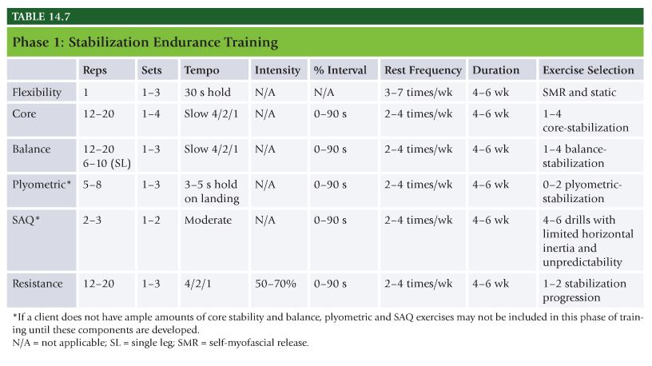
Strength
- Second level of OPT model, focuses on main adaptation of strength, includes strength endurance, hypertrophy, and maximal strength.
- Designed to maintain stability while increasing amount of stress placed on the body for increased muscle size and strength.
- Necessary progression for anyone who desires to increase caloric expenditure, muscle size, muscle strength, and bone mineral density.
- Focus of strength level training is to: increase ability of core musculature to stabilize the pelvis and spine under heavier loads, through more complete ranges of motion.
- Increase load bearing capabilities of the muscles, tendons, ligaments, and joints.
- Increase the volume of training.
- Increase metabolic demand by taxing the ATP-PC and glycolysis energy systems to induce cellular changes in muscle.
- Increase motor unit recruitment, frequency of motor unit recruitment, and motor unit synchronization(maximal strength)

Strength Endurance Training (Phase 2)
- Hybrid form of training that promotes increased stabilization endurance, hypertrophy, and strength.
- Entails use of superset techniques in which a more stable exercise(such as bench press) is immediately followed with a stabilization exercise with similar biomechanical motions(such as stability ball push-ups).
- Thus for every set of exercise/body part performed according to the acute variables, there are actually two exercises or sets being performed.
- High amounts of volume can be generated in this phase of training.
- Similar to phase 1, acute variables can be progressed by increasing proprioceptive demand, volume, sets, reps, and intensity, and by decreasing rest periods. Client will generally stay in this phase for 4-6 weeks.
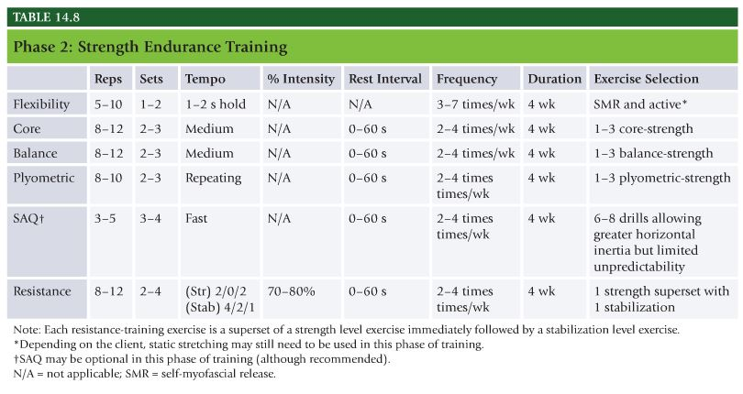
Hypertrophy Training (Phase 3)
- Hypertrophy training is specific for the adaptation of maximal muscle growth, focusing on high levels of volume with minimal rest periods to force cellular changes that result in overall increase in muscle size.
- Acute variables can be progressed if client with goal of increasing lean body mass and general performance has properly progressed through phases 1 and 2 of OPT model.
- Because goal of this phase is primarily hypertrophy, the fitness professional will want to increase volume and intensity of the program. Client will stay in for 4 weeks before cycling back through phase 1 or 2 or progressing on to phase 4 or 5.
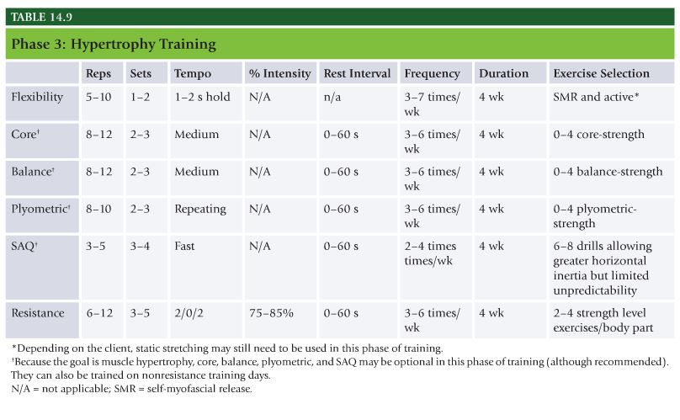
Maximal Strength Training (Phase 4)
- Maximal strength training phase focuses on increasing the load placed on tissues of the body.
- Maximal intensity improves: recruitment of more motor units, rate of force production, motor unit synchronization
- Maximal strength training has also been shown to help increase the benefits of power training used in Phase 5. Goal of this phase is primarily maximal strength, trainer will want to increase load and volume. Rest periods may need to be increased as client trains with heavier loads. Client will stay in this phase for 4-week duration before cycling back through Phase 1 or 2 or progressing on to phase 5.
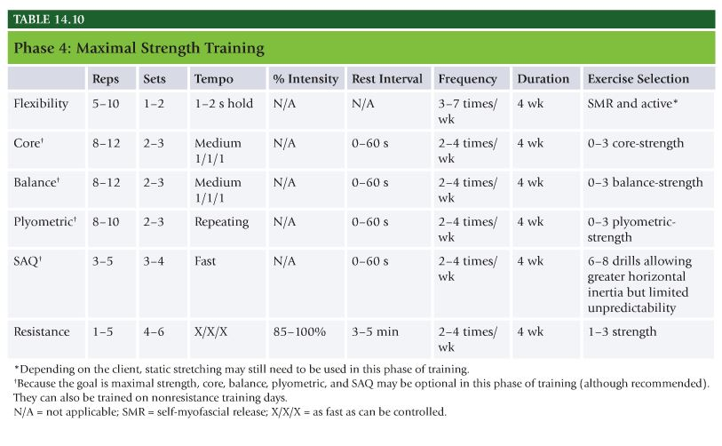
Power
- Designed to increase the rate of force production(or speed of muscle contraction). Uses the adaptations of stabilization and strength acquired in previous phases of training and applies them with more realistic speeds and forces that the body will encounter in everyday life and in sports.
- Not a common practice in the fitness environment, but has very viable and purposeful place in properly planned program.
- Increase in either force or velocity will produce an increase in power. Accomplished by increasing the speed at which you move a load, or increasing the load.
- Combined effect is better rate of force production in daily activities and sporting events.
- To develop optimal levels of power, individuals should train with heavy loads(85 to 100%) and light loads(30 to 45%) at high speeds.
- Focus of power training is to increase the rate of force production by increasing the number of motor units activated, the synchrony between them, and the speed at which they are excited.

Power Training (Phase 5)
- Power training phase focuses on both high force and velocity to increase power. Accomplished by combining a strength exercise with power exercise for each body part(such as barbell bench press superset with medicine ball chest pass).
- Range of training intensities is important to stimulate different physiologic changes. 85 to 100% refers to intensity for traditional strength training exercises. 30 to 45% is used for “speed” exercises.
- Goal of this phase is power, trainer will want to progress by increasing volume(sets), intensity(load), and velocity. Client will stay in this category for 4 week duration before cycling back through Phase 1 or 2.
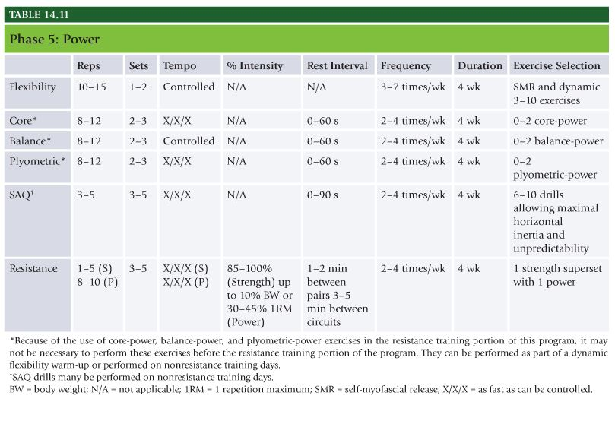

Applying the OPT Model
Applying the OPT Model for the Goal of Body Fat Reduction
- Goal of reducing body fat requires clients to follow the simple principle of burning more calories than they consume. Best way to increase calories burned is to move more.
- Weight training provides potent means to burn calories when it is combined with cardiorespiratory training by maintaining or even increasing lean muscle tissue. More activity and greater amounts of lean body mass result in more calories burned during exercise and throughout the day.
- The following program is a general representation of how the OPT model is used for clients with the goal of body fat reduction. Because goal does not include maximal strength or power, client only needs to be cycled through first two phases of OPT model, with phase 3 as optimal phase.
- Cardiorespiratory training will be used in conjunction with the OPT model to help weight-loss clients burn calories and improve health. Clients will progress through stages I, II, and III as their fitness levels improve.

Applying OPT model for increasing lean body mass
- Muscle hypertrophy can be defined as chronic enlargement of muscles. To accomplish this goal, training programs need to be progressed with higher volumes(more sets, reps, and intensity) to force muscles to regenerate their cellular makeup and produce increased size.
- With goal of increased lean body mass, client can be cycled through first four phases of OPT model.

Applying OPT Model for Improving General Sports Performance
- Goal of improving general sports performance requires client to increase overall proprioception, strength, and power output(rate of force production). Training will need to be progressed from stabilization through power phases of training.
- Phases 1, 2, and 5 will be most important.
- Phase 1 and 2 are vital and will prepare connective tissues and muscles for higher demands of training to follow. Without proper prep injury will be imminent.

NASM Study Guide Chapter 15 – Introduction to Exercise Modalities

Chapter 15 Introduction to Exercise Modalities:
There are no specific study tips for chapter 15, but be sure to be familiar with the different modalities such as:
- Machines
- Free weights
- Bands and rubber tubbing
- Cable Machines
- Medicine Ball
- Kettlebell
- Body weight training
- TRX suspension training
- BOSU
You will not see very much on the exam for this chapter but it will help you with categorizing exercise for resistance, core, and reactive training.
Strength Training Machines
- Safer option than free weights. Machine of choice for those who lack stability. Can change the load quickly.
- Inferior to free weights for improving core stability and neuromuscular efficiency(proper movement patterns). Can limit effectiveness of exercise and create more stress on joints because not all machines are created to accommodate all body types.
- Trainers should strive to progress individuals into more proprioceptively enriched environment while emphasizing multiple planes of motion.

Free Weights
- Perform exercises with full range of motion. Enhance motor learning and improve overall neuromuscular efficiency and performance. More easily progressed. Allow individuals to perform multijoint exercises(complex movements). Complex movements require more energy and enables individuals to expend more calories in a short period.
- Free weights can offer many benefits such as improving postural stability, strength, and muscle size and power, they can be potentially dangerous for novice exercises until proper technique is mastered.

Cable Machines
- Offers similar freedom of movement but does not require a spotter. Each cable exercise must match muscle’s natural line of pull. For example when performing biceps curl(elbow flexion), cable should be positioned to offer resistance in a vertical motion against elbow flexion.
- Can be effectively used in all phases(phase 1-5)
- Excellent option to challenge the core while having individuals perform exercises in standing position versus seated.

Elastic Resistance (Rubber Tubing and Bands)
- Inexpensive alternative to training with resistance. Various forms can help improve proprioceptive demands, muscular endurance, and joint stabilization. Not ideal for improving maximal strength, but it has been shown to be very beneficial to helping improve muscular strength and endurance for fitness and rehab purposes.
- Helps clients move in multiple planes of motion and oftentimes achieve a greater range of motion (ROM) during training.
- Tension is not consistent with elastic bands.

Medicine Balls
- Can be used with variety of populations as part of program to increase muscular strength, endurance, and power.
- Ability to develop explosive power is one of the unique benefits of medicine balls because velocity of movement is critical to developing power.

Kettlebell Training
- Benefits – Enhanced athleticism, coordination, and balance. Increased mental focus and physical stamina, increased oxygen uptake, increased total body conditioning. Recruitment of posterior chain. Increased core stability and muscular endurance. Increased strength and power. Increased grip strength. Increased metabolic demands and caloric expenditure.
- Kettlebell Program Design Strategies – Skilled lifts, must hone skills first. Emphasis on posterior chain, working from ground up, and keeping perfect form is top priority. Quality should come before quantity.
- Five checkpoints – feet shoulder width apart pointed straight ahead, knees in line with second and third toes, hips level with lumbar spine and in neutral position, shoulders depressed and slightly retracted to activate scapulae, head cervical spine in neutral position(chin tuck)

Body Weight Training
- Can learn how to train in all planes of motion and acquire greater kinesthetic awareness.
- Suspension bodyweight training – increased muscle activation, low compressive loads to spine, increased performance, potential increase in caloric expenditure, improvements in cardiovascular fitness
- Ideal for phases 1 and 2 of OPT model.

Introduction to Proprioceptive Modalities
Stability Balls
- Swiss balls, allows increase in strength and stability of the core musculature when substituted for more stable surfaces such as exercise benches, chairs, and the floor.
- The unstable base of support forces user to constantly adjust body position to subtle movements of the ball.
- Can be dangerous if one does not possess good balance or control.

Bosu Balls
- Stands for both sides up.
- Ability to increase intensity of an exercise by decreasing the stability. Increases neuromuscular activity when compared with standing on a stable surface.

NASM Study Guide Chapter 16 – Chronic Health Conditions and Physical or Functional Limitations

Chapter 16 Chronic Health Conditions and Physical or Functional Limitations:
For this chapter, read through the text and highlight the training guidelines and have a general idea on how to design a program for the special populations mentioned in this particular chapter. Don’t worry too much about the acute variables (reps, sets, tempo, etc.) but rather on contraindications and more appropriate techniques for these populations.

Age Considerations
- Children and adolescents should get 1 hr or more of physical activity daily.

Physiologic Differences between Children and Adults
- Children do not exhibit plateau in oxygen uptake, peak oxygen uptake is more appropriate.
- Children less efficient, tend to exercise at higher percentage of peak oxygen uptake during submaximal exercise.
- Do not produce sufficient levels of glycolytic enzymes to sustain bouts of high-intensity exercise.

Resistance Training for Youth
- Resistance training is both safe and effective in children and adolescents.
- Untrained children can improve strength by 30 to 40% in 8 weeks.

Seniors
- Older adults with and without other chronic health conditions can and do respond to exercise much in the same manner as apparently healthy younger adults.
- Walking is one of most fundamental functional activities affected with degenerative aging.
- Musculoskeletal loss not entirely related to aging.
- Complete PAR-Q. Assessments.
- Progression should be slow, well monitored, based on postural control. Exercises should be progressed if possible toward free sitting or standing. If client cannot tolerate SMR perform slow rhythmic active or dynamic stretches.

Obesity
- Flexibility exercises should be performed from standing or seated position, using standing hip flexor stretch rather than kneeling hip flexor stretch, standing hamstring stretch, wall calf stretch.
- Core and balance training important for obese individuals.
- May find it difficult to use machines, dumbbells, cables, exercise tubing work quite well.

Diabetes
- Most important goal is glucose control. Exercise improves insulin sensitivity. Positive effect on prevention of type 2 diabetes.
- Take care to prevent blisters and foot microtrauma that could result in foot infection.
- Daily exercise recommended. Flexibility exercises recommended.
- Follow exercise guideline for obese adults. Lower impact exercise modalities.

Hypertension
- Low to moderately intense exercise just as effective as high intensity activity in reducing blood pressure.
- Important to monitor body position of clients with hypertension at all times. Body position can have dramatic effect on blood pressure response before, during, and after exercise in clients with hypertension.
- Avoid heavy lifting and valsalva maneuvers. Do not let client overgrip weights or clench fists. Modify tempo to avoid extended isometric and concentric muscle action. Perform exercises in standing or seated position. Allow client to stand up slowly to avoid possible dizziness. Progress client slowly.

Coronary Heart Disease
- Monitor pulse to stay below safe upper limit of exercise.
- Clients may have other diseases to consider as well, such as diabetes, hypertension, peripheral vascular disease, or obesity
- Modify tempo to avoid extended isometric and concentric muscle action
- Avoid heavy lifting and Valsalva maneuvers
- Do not let client overgrip weights
- Perform exercises in standing or seated position
- Progress slowly

Osteoperosis
- Progress should be slow, well monitored, based on postural control
- Exercises should be progressed if possible toward free sitting(no support) or standing
- Focus exercises on hips, thighs, back, and arms
- Avoid excessive spinal loading on squat and leg press
- Make sure client is breathing in normal manner and avoid holding breath in Valsalva maneuver

Arthritis
- Avoid heavy lifting and high reps
- Stay in pain-free ranges of motion
- Only use SMR if tolerated by client
- May be need to start out only with 5 mins of exercise and progressively increase

Cancer
- Avoid heavy lifting in initial stages of training
- Allow for adequate rest intervals and progress client slowly
- Only use SMR if tolerated, avoid SMR for clients undergoing chemo or radiation
- May be need to start out with only 5 mins of exercise and progressively increase

Exercise and Pregnancy
- Avoid exercises in prone or supine position after 12 weeks
- Avoid SMR on varicose veins and areas of swelling
- Plyometric training not advised in second and third trimesters

Chronic Lung Disease
- Upper body exercises cause increased dyspnea and must be monitored
- Allow for sufficient rest between sets

Intermittent Claudication/Peripheral Arterial Disease
- Allow for sufficient rest
- Workout may start with 5-10 mins of activity
- Progress slowly
- Treadmill walking preferred.
- Primary limiting factor is leg pain.

NASM Study Guide Chapter 17 – Nutrition

Chapter 17 Nutrition
- Know all Definitions throughout the chapter
- Table 17.4 Know all of the Essential Amino Acids
- Table 17.6 Recommended Protein Intake
- Daily recommendations for fiber
- Specific recommendations for endurance athletes
- Fatty acids
- Lipids in the body
- Daily recommendations and importance of water
- Table 17.11The effects of dehydration
- Be familiar with guidelines for altering body composition
- Risks of very low calorie diets
- Calorie count for proteins, carbohydrates, fats

Definition
- Nutrition – Process by which living organism assimilates food and uses it for growth and repair of tissues.

Standards of Practice and Scope of Practice: Personal Trainers versus licensed Dieticians
- Should be familiar with concepts of nutrition.
- Professional, legally qualified to practice in the field of nutrition is Registered Dietician(RD). RD is specialized in food and nutrition expert with extensive training.
- Practice of nutrition is governed by national credentialing programs and state licensing laws. 46 states have specific laws that explicitly define scope and practice for nutrition and dietetics professionals, and performing these duties without a license could be considered illegal.

Daily Energy Needs
- Calorie – amount of heat energy required to raise temp of 1 gram of water 1C.
- Calorie – Unit expression of energy equal to 1,000 calories. Amount of heat energy required to raise 1 KG or liter of water 1C or kilocalorie.
- Kilocalorie – equal to 1,000 calories, raise 1kg of water 1 degree C.
- Estimated total energy expenditure(TEE) is defined as amount of energy(calories) spent, on average, in a typical day. TEE the sum of three different energy components:
- Resting metabolic rate(RMR) 70% of TEE., Thermic effect of food(TEF) amount of energy expended above RMR as a result of processing of food, TEF typically accounts for 6-10% of TEE. Energy expended during physical activity – Approx 20% of TEE.

Resting metabolic rate
- Accounts for 70% of total daily energy expenditure in sedentary person. Affected by wide variety of factors including age, sex, genetics, hormonal changes, body size, body comp.
- 27 million Americans have thyroid related disorders.
- Cardiovascular meds can reduce RMR from 4 to 12%. Chemo can reduce RMR from 6 to 11%. Long term use of growth hormone increases RMR by 12%. Thyroid meds and hypothyroidism can increase RMR by 17%.
- Thermic effect of food – Process of digestion requires energy, increase in energy expenditure after meal is called thermic effect of food (TEF) 6-10% of total energy expenditure.

Estimating Total Daily Energy Expenditure
- Weight(lbs) x 10 = RMR
- RMR x activity factor = TEE
- Even most commonly used formulas can have up to 20% variance in over or underestimating resting metabolism and total energy expenditure.

Protein
- Protein – Amino acids linked by peptide bonds. Build and repair body tissues and structures. Involved in synthesis of hormones, enzymes, and other regulatory peptides.

Structure of Protein
- Made up of amino acids linked together by peptide bonds. Body uses approx 20 amino acids to build its many different proteins. Arranging amino acids in different sequences yields the body’s myriad of proteins.
- Two general classes of amino acids: essential and nonessential.
- Essential amino acids cannot be manufactured in the body – therefore must be obtained from food supply or some other exogenous source.
- Nonessential – body can manufacture them from dietary nitrogen and fragments of carbs and fat.
- Arginine and histidine are semi-essential amino acids.
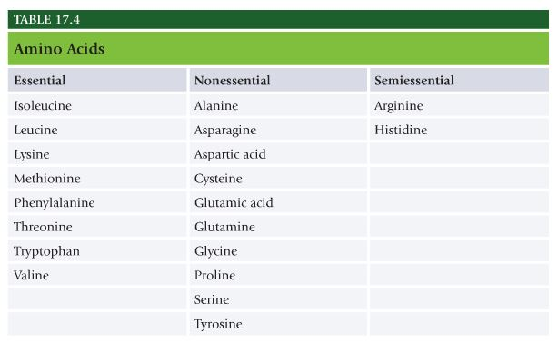

Digestion, Absorption, and Utilization
- Proteins must be broken down into constituent amino acids before body can use them or repair tissue or as energy substrate. Fate of amino acids after digestion depends on body’s homeostatic needs, which can range from tissue replacement or tissue addition to need for energy.
- Proteins encounter HCL in stomach which uncoils(denatures) protein so that digestive enzymes can begin dismantling peptide bonds. The enzyme pepsin begins to cleave protein strand into smaller polypeptides(strands of several amino acids) and single amino acids.
- As protein fragments leave stomach and enter small intestine, pancreatic and intestinal proteases(protein enzymes) continue to dismantle the protein fragments.
- Resulting dipeptides, tripeptides, and single amino acids are then absorbed through the intestinal wall into enterocytes and released into the blood supply to the liver.
- Once in bloodstream, free-form amino acids have several possible fates: they can be used for protein synthesis(building and repairing tissues or structures), immediate energy, or potential energy(fat storage).
- Amino acids are first deaminated(stripped of amine group), allowing remaining carbon skeleton to be used for production of glucose or ketones to be used for energy. Removed amine group produces ammonia, which is converted to urea in the liver and excreted as urine by the kidneys.
- If intake exceeds need for synthesis, then proteins are deaminated, carbon fragments stored as fat.

Protein in Foods
- If food supplies all essential amino acids in appropriate ratios it is called complete protein. If food source is low or lacking in one or more essential amino acids it is called incomplete protein.
- Biologic value (BV) measure frequently used when discussing protein sources, BV is measure of protein quality, how well it satisfies body’s essential amino acid needs.
- Protein source with higher score provides amino acid profile that is more closely related to needs of the human body.
- Major sources of complete proteins are animal sources, dairy and meats. Sources of incomplete protein include grains, legumes, nuts, seeds, and other vegetables.

Negative Energy Balance
- During negative energy balance amino acids are used to assist in energy production, a term called gluconeogenesis. Depleted glycogen increases gluconeogenesis. Supported by released of amino acids from structural proteins to maintain glucose homeostasis.

Protein’s Effect on Satiety
- More satiating than fat or carbs. Studies indicate protein has direct effect on satiety.

Protein Intake Recommendations
- Recommended Daily Allowance(RDA) for protein is 0.8 g/kg/day. 10 to 35% of total caloric intake.
- High protein diet defined as higher than 35%. Risk factor for heart disease and some types of cancer.
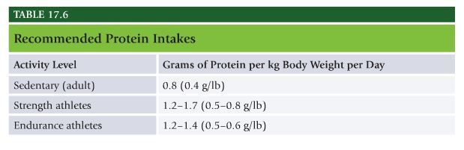

Carbohydrates
- Carbohydrates – Neutral compounds of carbon, hydrogen, and oxygen(such as sugars, starches, and celluloses), which makes up a large portion of animal foods.
- Sugars(simple), starches(complex), and fiber. Monosaccharide is single unit of sugar, many of which are connected to make starches. Monosaccharides include glucose, fructose, and galactose.
- Disaccharides(two sugar units) include sucrose(or common sugar), latose(or milk sugar), and maltose.
- Polysaccharides are long chains of monosaccharide units linked together and found in foods that contain starch and fiber. Called complex carbohydrates and include starch found in plants, seed, and roots.
- Dietary fiber is part of plant that cannot be digested by human gut enzymes and passes through small intestine and colon.

Digestion, Absorption, and Utilization
- Simple sugars are very easily digested. Double sugars such as table sugar require some digestive action but are not nearly as complex as starches. Starches require prolonged enzymatic action to be broken down into simple sugars.
- Rate at which ingested carbs raise blood sugar and its accompanying effect on insulin release is referred to as the glycemic index(GI).
- Mixed meals or protein, carbs, and fat can alter the glycemic effect of single foods.
- All carbs are eventually converted into simple sugars such as glucose or fructose.

Role of Fiber in Health
- Higher fiber intake is associated with lower incidence of heart disease and certain types of cancer.
- Insoluble fiber does not absorb or dissolve in water. It passes through the digestive tract close to its original form. Insoluble fiber offers many benefits to intestinal health, including a reduction in the risk and occurrence of colorectal cancer, hemmrrhoids, and constipation.

Carbs and Performance
- As duration of activity increases, available glucose and glycogen diminish. Increasing reliance on fat as fuel source.

Carbohydrate Intake Performance
- 6 and 10g/kg/day of carbs is recommended. 45 to 65% of total caloric intake. Complex carbs constitute majority of calories.
- Before exercise consume high carb meal 2 to 4 hours. Glycogen stores are lowered by as much as 80% in the mornings.
- Endurance athletes consume between 30 and 60g of carbs every hour to maintain blood glucose levels.
- One hour of intense cycling was improved by 12% with consumption of 53 ounces of water containing 79g of carbs.
- Timing of carbs important for maximizing recovery, recommended consuming 1.5g per KG of carbs within 30 mins of completing exercise to maximize glycogen replenishment. Delaying intake by even 2 hours can decrease total muscle glycogen synthesis by 66%. PWO environment hasten glycogen repletion as a result of increased blood flow to muscles and increased sensitivity of cells to effects of insulin.

For altering body composition
- Bunch of bullshit that’s not true here. Yeah right high carb diets lead to fat loss? Let’s not even talk about insulin NASM!

Lipids
- Lipids – Group of compounds that includes triglycerides(fats and oils), phospholipids, and sterols.
Fatty Acids
- Saturated or unsaturated. Unsaturated classified as monounsaturated or polyunsaturated.
- Polyunsaturated provide important essential fatty acids(fats that cannot be manufactured by the body but are essential for proper health and functioning).

Function of Lipids
- Lipids(or fats) are most concentrated source of energy in the diet. One gram of fat yields approximately 9 calories when oxidized.
- Fats act as carries for fat-soluble vitamins A, D, E, and K. Vitamin D aids in absorption of calcium. Fats are also important for conversion of carotene to vitamin A.
- Fats are involved in: cellular membrane structure and function, precursors to hormones, cellular signals, regulation and excretion of nutrients in cells, surrounding protecting and holding in place organs, insulating body from environmental temp changes, prolonging digestive process by slowing stomach’s secretion of HCL, longer lasting feeling of satiety, initiating release of hormone cholecystokinin(CCK) which contributes to satiety.

Digestion, Absorption, and Utilization
- Fat becomes emulsified in intestine so that pancreatic enzymes can break triglycerides down into two fatty acids and a monoglyceride. These are absorbed through intestinal walls into blood.
- In intestinal wall they are reassembled into triglycerides that are then released into the lympth in the form of lipoprotein called chylomicron. Chylomicrons from the lymph move to the blood. Triglyceride content of chylomicron is removed by action of the enzyme lipoprotein lipase (LPL), and the released fatty acids are taken up by the tissues. Throughout the day triglycerides are constantly cycled in and out of tissues, including muscles, organs, and adipose.

Recommendations
- 20 to 35% of total calories from fat.
- Dietary fats stimulate release of CCK, hormone that signals satiety. Fat slow digestion of foods and thus nutrient content in the bloodstream.
- Medium chain triglycerides are more rapidly absorbed, they do not require incorporation into chylomicrons for transport but can enter systemic circulation directly providing readily avaialble, concentrated source of energy. MCT could benefit endurance performance by suppling exogenous energy source in addition to carbohydrates during exercise and increase plasma free acids(FFA), sparing muscle glycogen.

Water
- Sedentary men and women should consume 3L (13 cups) and 2.2L(9 cups) of water per day. Those in fat loss programs should drink additional 8 ounces of water for every 25 pounds they carry above their ideal weight. Water intake should be increased if individual is exercising briskly or residing in a hot climate.
- 60% of adult human body by weight.
- Benefits of consuming adequate water: endocrine gland function improves, fluid retention is alleviated, liver functions improve, natural thirst returns, metabolic functions improve, nutrients are distributed throughout body, body-temperature regulation improves, blood volume is maintained.
- Fluid loss of 2% of body weight will adversely affect circulatory functions and decrease performance levels. Thirst alone is poor indicator of how much water is needed.
- Athletes consistently consume inadequate fluid volume, managing to replace only 50% of sweat losses. Do not being practice session or endurance comp until body is at or slightly above standard weight.
- Drink 1.75 to 2.75 cups 2 hours before exercise. Drink 6 to 12 ounces of fluid every 15 to 20 minutes. Fluids should be cold because of more rapid gastric emptying.
- If exercise exceeds 60 mins use sports drink(containing up to 8% carbohydrate).
- When exercising for less than 60 minutes, water is experts’ choice for fluid replacement
- Ingest 16 to 24 ounces of fluid for every pound of body weight lost after an exercise bout, especially if rapid rehydration is necessary, as in twice-a-day training.
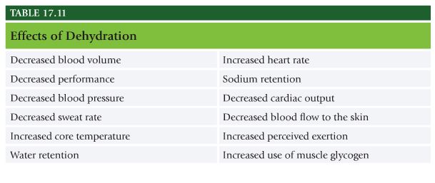

Altering Body Composition
Basic nutritional guidelines for altering body composition for fat loss
- Small decreases in food and beverage calories and increase physical activity.
- Distribute protein, carbs, and fat throughout day.
- Consume less than 10% of cals from saturated fat.
- Choose whole grains and fiber rich fruits and veggies over refined grains and simple sugars.
- Limit alcohol.
- Schedule no fewer than four and as many as six meals a day.
- Avoid empty calories and highly processed foods.
- Drink plenty of water(minimum 9 to 13 cups a day)
- Have clients weigh and measure food at least 1 week. Make them more aware of caloric values and serving sizes.

For lean body mass gain
- 4-6 meals a day. Spread protein intake throughout day.
- Post workout window of opportunity, ingestion of proteina nd carbs within 90 mins of a workout will increase recovery and protein synthesis, maximizing gains.
- Do not neglect importance of carbs and fat.
Risks of Starvation(low cal) Diets
- Nutrition experts do not recommend energy intake lower than 1,200 calories.
- Increased risk of malnutrition, poor energy and inability to complete essential fitness program, behavioral pendulum swing, minor side effects as fatigue, constipation, nausea, diarrhea. Gallstone formation.

NASM Study Guide Chapter 18 – Supplementation

Chapter 18 Supplementation:
- Table 18.2 Dietary reference intake terminology
- Units of measure used on dietary supplement labels
- Adverse effects of excess for specific vitamins & minerals
- Be familiar with the ergogenic aids and dosage

Dietary Supplements
What are supplements
- Dietary Supplement – Substance that completes or makes an addition to daily dietary intake.
- Defined by DSHEA as containing one or more of following: vitamin, mineral, herb, other botanical, amino acid, dietary substance to supplement diet, concentrate, metabolite, constituent, or extract. Intended for ingestion in a tablet, capsule, powder, softgel, gelcap, or liquid form. Labeled as dietary supplement. Cannot be represented for use as a conventional food or as a sole item of a meal or diet. Cannot include an article that is approved as a drug or biologic.

Supplementation Guidelines
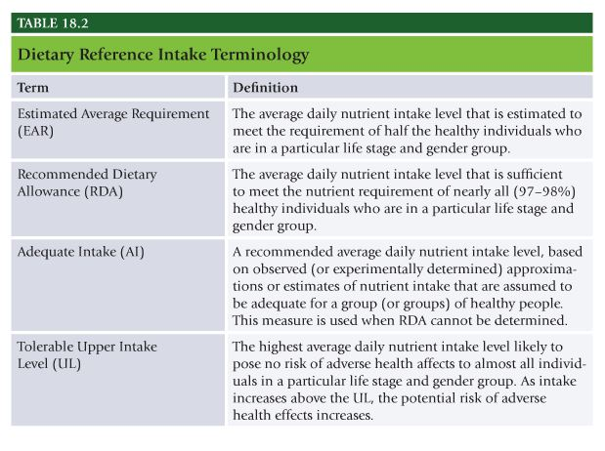

Labels of Dietary Supplements
- Proteins, carbs, fats expressed in grams
- Vitamins, minerals, amino acids are expressed in milligram(mg) or microgram(mcg or ug)
- IUs are international units.

Vitamin and Mineral Supplements
- Vitamin A – high intake of retinol but not Beta carotene is associated with increased incidence of hip fracture in older women. Excess intake of retinol at conception and during early stages of pregnancy increases risk of birth defects.
- Increase in risk of lung cancer in smokers taking 20 to 30mg of beta carotene.
- Calcium should be at low levels or absent. Excess calcium consumed with other minerals can decrease absorption of some important trace minerals.
- B vitamins, niacin, folic acid.
- Deficiency of vitamins and minerals can cause mental and emotional problems. Iron deficiency has been shown to affect both physical and mental function adversely.
- Vitamin B12 deficiency, most commonly seen in elderly and those who avoid consuming animal foods. Mental and emotional changes caused by vitamin B12 deficiency are often mistaken for Alzheimer’s and dementia. Condition can be reversed if corrected early in deficiency state. If not, nerve damage and dementia symptoms can be irreversible. High dose oral supplementation, 200 to 2000 ug per day may be as effective as injections.

Ergogenic Aids
- Ergogenic means work generating. Something that enhances athletic performance.
- Creatine – synthesized naturally in human body from amino acids methionine, glycine, and arginine. In resting skeletal muscle, about two thirds of creatine exists in a phosphorylated form that can rapidly regenerate ATP to maintain high-intensity muscular efforts for up to about 10 seconds.
- When creatine supplementation is combined with strength-training program, it has been shown to increase muscle mass, strength, and anaerobic performance. Typical dose begins with 5 to 7 days at 20g per day then followed by 2 to 5g a day to sustain maximal muscle creatine levels.
- Consuming creatine with carbs can enhance muscle uptake of creatine and potentially increase muscle levels above that achieved without concurrent carb consumption.
- Creatine plays an essential role in normal brain function.

Stimulants
- Caffeine – most widely used drug in the world. Acts as stimulant, primarily affects central nervous system, heart, and skeletal muscles.
- Ergogenic effects from caffeine, especially when tested on well-trained athletes performing endurance exercises(more than one hour) or high intensity short-duration exercise lasting about 5 minutes. Does not appear to be ergogenic effect on sprint type efforts lasting 90 seconds or less.
- Most effective ergogenic response observed when dose of caffeine is 3 to 6 mg per kg body weight, ingested 1 hour before exercise. For 155lb person this is 210 to 420mg of caffeine.

NASM Study Guide Chapter 19 – Lifestyle Modification and Behavioral Coaching

Chapter 19 Lifestyle Modification and Behavioral Coaching:
- Figure 19.1 Stages of Change Model
- Know the stages of Change
- Be familiar with the initial session
- Effective Communication skills
- Goal setting- SMART Goals
- Cognitive Strategies
- Positive Self talk
- Exercise Imagery

States of Change
Stage 1: Precontemplation
- No intention of changing. Do not exercise and do not intend to start within 6 months. Education is best strategy with precontemplators.

Stage 2: Contemplation
- Thinking about becoming more active in next 6 months. Listen to what contemplators need and support them any way that they can. Contemplators still need information.

Stage 3: Preparation
- Exercise occasionally but are planning to begin exercising regularly next month. May have unrealistic expectations for the change they hope to achieve, oftentimes leads to high risk of disappointment and early dropout.
- Help clients clarify realistic goals and expectations, help clients maintain their beliefs in the importance of exercise, discuss programs that work best for different clients, consider clients’ schedules, ask about previous successful experiences with exercise, avoid exercise that could lead to discomfort or injury, discuss building social support network.

Stage 4: Action
- Started exercise, but not yet maintained behavior for 6 months. Continue to provide them with education. Work with their clients to develop steps for overcoming any barriers or disruptions.

Stage 5: Maintenance
- Maintained change for 6 months or more. Still tempted to return to old habits.

The Initial Session
- 20 seconds to make a good first impression. Body language. Initial session building relationship.
- Discuss health concerns.
- Clarify fitness goals. Verbalize goals. Set SMART goals, specific, measurable, attainable, realistic, and timely.
- Reviewing previous exercise experiences
- Finalizing program design. Have good sense of health concerns, fitness goals, and past positive and negative experiences.
- Help clients anticipate the process.

Importance of Effective Communication Skills
- Difference between success and failure in relationship between trainer and his or her client.
- Nonverbal and verbal communication – posture, body language, verbal must be clear to be understood correctly.
- Active listening – genuine interest in client’s perspective and getting to know them. Pay attention, avoid distractions, look the speaker in the eye.
- Asking questions – ask open not close ended questions.
- Reflecting – Express the purported meaning of what you just heard. Make sure client is accurately understood.
- Summarizing – Draws all important points of conversation together and again allow clients to clarify either what they have said or how someone has interpreted what they have said.
- Affirmations show appreciation for clients and their strengths. Listen carefully to know what to affirm. Validate positive comments about their thoughts, plans, skills.
- Asking permission – ask permission to share information.

SMART Goals
- Specific – clearly defined in such a way anyone could understand what the intended outcome is. Detailed description of what is to be accomplished.
- Measureable – Quantifiable. Establish a way to access the progress toward each goal. If goal cannot be measured a client cannot manage it.
- Attainable – Right mix of goals that are challenging, but not extreme.
- Realistic – Repesent objective toward which an individual is both willing and able to work.
- Timely – Always have a specific date of completion. Realistic but not too distant in the future.

Cognitive Strategies
- Positive self-talk – Help clients become aware of their negative thought process. Help clients come up with list of positive thoughts they might use with regard to exercise. Train clients to notice negative thoughts, stop negative thoughts, and translate those into something positive.
- Exercise imagery – process created to produce internalized experiences to support or enhance exercise participation. Clients can imagine themselves approaching their activity with greater confidence. Visualize performing with greater relaxation and muscle control. Rehearse positive outcomes.

NASM Study Guide Chapter 20 – Developing a Successful Personal Training Business

Chapter 20 Developing a Successful Personal Training Business:
- Providing uncompromising customer service
- Know who your customers are
- Ten steps to success

Providing Uncompromising Customer Service
- Unwavering in providing experience and level of assistance that is rarely, if ever, experienced anywhere else.
- Take every opportunity to get to know all potential clientele.
- Represent a positive image and high level of professionalism every minute of the day.
- Never give impression that any question is inconvenient, unnecessary, or unintelligent.
- Express ideas well through verbal communication, vocal tonality, and body language.
- Obsess on opportunities to create moments that strengthen professional relationships.
- Do not merely receive complaints, but take ownership of them.

Know Who Your Customers Are
- Everybody is your potential client.
- Don’t be afraid to approach potential clients. Say hi to everyone, make eye contact, etc.

10 Steps to Success
- Step 1 – What is desired annual income?
- Step 2 – How much must be earned per week to achieve the annual goal?
- Step 3 – Earn the weakly goal, how many sessions need to be performed?
- Step 4 – What is the closing percentage?
- Step 5 – In what Timeframe will new clients be acquired?
- Step 6 – How many potential clients need to be interacted with overall to gain clients within the timeframe?
- Step 7 – How many potential clients need to be contacted each day?
- Step 8 – How many potential clients need to be contacted each hour of the day?
- Step 9 – Ask each member spoken to for his or her contact information.
- Step 10 – Follow up.

